

**HEY DOC!**

**Mental Health and Therapy Management App**

**By**

Niranjan K S (2141025)

Nandana Pradeep (2141054)

Sandra Benny (2141058)

(5BCA-A)

**Bachelor of Computer Science**

**Under the supervision of**

**GUIDE NAME**

Dr. Saravanakumar K

**Department of Computer Science**

**CHRIST** (**Deemed to be University)**

**Bengaluru, India**



**CERTIFICATE**

*This is to certify that the report titled* ***HEY DOC*** *is a bona fide record of work done by* ***Niranjan K S(2141025), Nandana Pradeep(2141054), and Sandra Benny(2141058)*** *of CHRIST (Deemed to be University), Bangalore, in partial fulfillment of the requirements of V Semester BCA during the year 2023.*

**Head of the Department Project Guide**

Valued-by:

|  |  |  |  |
| --- | --- | --- | --- |
|  |  | Name | : Niranjan K S, Nandana Pradeep, Sandra Benny |
| 1. |  | Register Number | : 2141025, 2141054, 2141058 |
| 2. |  | Examination Centre | : CHRIST(Deemed to be University) |
|  |  | Date of Exam | : |

**ACKNOWLEDGMENT**

First of all, we thank God the Almighty for his immense grace and blessings showered on us at every stage of this work.

We extend our heartfelt gratitude to **Dr. Ashok Immanuel V**, the Head of the Computer Science Department at CHRIST (Deemed to be University), for his unwavering support and guidance throughout our project and to **Dr. Beaulah Soundarabai P**, the Coordinator of the Computer Science Department, for her invaluable insights and encouragement. Her dedication to fostering excellence in education has inspired us to strive for innovation and excellence in our work.

Our profound appreciation goes to our project guide, **Dr. Saravanakumar K**, Associate Professor in the Computer Science Department at CHRIST (Deemed to be University). His mentorship, expertise, and unwavering support have been instrumental in steering our project towards its goals.

Lastly, we would like to extend our gratitude to all the faculty and staff members of the Computer Science Department at CHRIST (Deemed to be University) for their constant support, encouragement, and valuable input. Their collective efforts have created a conducive learning environment that has enriched our educational journey.

Last but not least, we would like to thank everyone who is involved in the project directly or indirectly.

**ABSTRACT**

In an era where mental health concerns have reached critical levels, our innovative mental health and therapy management app, "HEY DOC," emerges as a beacon of hope and support for individuals seeking emotional well-being. We offer a multifaceted solution that connects users with certified mental health professionals, provides companionship through student volunteers, and an array of relaxation resources, including guided meditations .

One of the core features of "HEY DOC" is its seamless connection to certified mental health practitioners, allowing users to access therapy sessions that suit their specific needs and preferences. This professional guidance empowers individuals to navigate life's challenges more effectively, improving their overall mental health. Moreover, we acknowledge the significance of human connection and provide a platform for users to engage with compassionate student volunteers when loneliness strikes, fostering a sense of belonging and community.

By combining therapy, companionship, and relaxation resources within one user-friendly app, HEY DOC aspires to reshape the way we address mental health, striving for a future where emotional well-being is accessible, destigmatized, and nurtured, one user at a time.

**TABLE OF CONTENTS**

Certificate……………………………………………………………………………..ii

Acknowledgement……………………………………………………………….…...iii

Abstract……………………………………………………………………………….iv

Table of Contents………………………………………...……………………………v

List of Tables………………………………………………………………………….vi

List of Figures…………………………………………………….…………………..vi

1. Introduction 1

1.1 Overview of the system 1

2. System Analysis 2

2.1 Existing System 2

2.2 Proposed System 3

2.2.1 Benefits of Proposed System 3

2.3 Functional Requirements 5

2.4 Software and Hardware Requirements 6

3. System Design 7

3.1 Database Design 7

3.2 ER Diagram 16

3.3 Data Flow Diagram 17

3.4 Pert Chart 18

3.5 Gantt chart 18

4. Implementation 19

4.1 Source Code 19

4.2 Screen Shots 42

5. Testing 47

5.1 Test Strategies 47

5.2 Test Cases and Reports 49

6. Conclusion 49

References 50

**LIST OF TABLES**

|  |  |  |
| --- | --- | --- |
| **Table No.** | **Title** | **Page No.** |
| 1. | Signup_Details | 7 |
| 2. | Doctor_signUp | 8 |
| 3. | Psych_profileDetails | 9 |
| 4. | Users | 10 |
| 5. | Review_Doctors | 11 |
| 6. | Review Psych_students | 11 |
| 7. | User_reviews | 12 |
| 8. | App_rating | 12 |
| 9. | Slot_booking | 13 |
| 10. | messaging | 14 |
| 11. | Messaging_depth | 14 |
| 12. | Auth_signIn | 15 |

**LIST OF FIGURES**

Fig 1. ER Diagram……………………………………………………………………16

Fig 2. Data flow Diagram…………………………………………………………….17

Fig 3. Pert Chart………………………………………………………………………18

Fig 4. Gantt Chart…………………………………………………………………….18

1. **INTRODUCTION**

Our Mental Health and Therapy Management System is a revolutionary digital solution designed to empower individuals to take control of their mental well-being. This innovative platform streamlines therapy access, personalizes care and ensures data security, making mental health support more accessible and effective than ever before.

* 1. **OVERVIEW OF THE SYSTEM**

Our Mental Health and Therapy Management System is a comprehensive digital platform that has been meticulously crafted to address the unique challenges and demands of mental health care and therapy. At its core, this system is built to provide individuals with a seamless and accessible gateway to mental health services. By removing geographical barriers and reducing scheduling conflicts, we aim to make therapy more convenient and readily available to those in need.

One of the distinguishing features of our system is its ability to personalize therapy recommendations. We understand that no two individuals are the same, and their mental health journeys are equally unique. To cater to this diversity, our system employs advanced algorithms and data analytics to assess individual needs and preferences, ensuring that therapy sessions are tailored to each user's specific requirements. This personalization enhances the overall effectiveness of therapy and increases the likelihood of positive outcomes.

Moreover, our system fosters collaboration between users and therapists, as well as other healthcare providers when necessary. Users can monitor their mental health progress, set achievable milestones, and receive feedback from their therapists, empowering them to actively participate in their therapy journey. In the subsequent sections, we will delve deeper into the specific features and functionalities that make this system a game-changer in mental health and therapy management.

1. **SYSTEM ANALYSIS**

Our Mental Health and Therapy Management System is a comprehensive digital platform that offers an intuitive user interface, personalized therapy recommendations for users and therapists’ goal-setting features, an extensive library of educational resources, robust data security, scalability to meet increasing demand, and dedicated user support. This holistic approach empowers individuals to access therapy and mental health resources conveniently, fosters engagement in therapy enhances treatment outcomes, and ensures the confidentiality and trustworthiness of user data, ultimately revolutionizing the way mental health care is delivered and experienced.

**2.1 EXISTING SYSTEMS**

* **BetterHelp**

https://www.betterhelp.com/

BetterHelp offers access to licensed, trained, experienced, and accredited psychologists (PhD/ PsyD), marriage and family therapists (LMFT), clinical social workers (LCSW / LMSW), and board licensed professional counselors (LPC).

* **Talkspace**

https://www.talkspace.com/

Talkspace is an online therapy platform that provides users with the confidential support of a licensed therapist through an easy-to-use and HIPAA-compliant app.

**2.2 PROPOSED SYSTEM**

The proposed Mental Health and Therapy Management System is a cutting-edge digital platform designed to revolutionize the mental health care landscape. This comprehensive system offers users the opportunity to engage in therapy sessions conducted by licensed and experienced mental health professionals, ensuring access to expert care and tailored treatment plans. Additionally, it fosters a supportive environment by allowing users to connect with psychology students for extra emotional support, reducing fear and loneliness. Furthermore, the system provides a wide range of meditation resources to promote stress reduction, improved focus, emotional regulation, and enhanced well-being. By integrating these features, the system aims to empower individuals to take control of their mental well-being, providing a holistic approach to mental health support and promoting positive mental health outcomes.

**2.2.1 BENEFITS OF PROPOSED SYSTEMS**

**1. Therapy Sessions by Experts:**

* Expertise: Users can benefit from the extensive knowledge and expertise of licensed therapists who are skilled in diagnosing and treating a wide range of mental health issues.
* Customized Treatment: Therapists can tailor treatment plans to address individual concerns and preferences, increasing the likelihood of positive outcomes.
* Evidence-Based Approaches: Professionals use evidence-based therapeutic techniques to provide effective and proven interventions for mental health challenges.
* Confidentiality and Privacy: Licensed therapists adhere to strict ethical and legal standards, ensuring the confidentiality and privacy of user information and discussions.

**2. Talk to a friend:**

Our system also offers the unique benefit of allowing users to engage with psychology students, providing an additional layer of support and understanding. While psychology students are not licensed therapists, their involvement can be highly beneficial in various ways:

* Reducing Fear and Loneliness: Engaging with psychology students can create a less intimidating and more approachable environment for users who may feel anxious or isolated when seeking therapy.
* Listening and Empathy: Students can lend a compassionate ear and offer empathy, which can be particularly valuable for users who need someone to talk to or confide in.
* Access to Future Professionals: Users have the opportunity to support the development of future mental health professionals while benefiting from a supportive and non-judgmental environment.

**3. Meditations:**

The inclusion of meditations as part of our system's offerings brings several mental health benefits:

* Stress Reduction: Guided meditations can help users reduce stress and anxiety, promoting a sense of calm and relaxation.
* Improved Focus: Meditation techniques can enhance concentration and mindfulness, which are valuable for managing racing thoughts or depressive symptoms.
* Emotional Regulation: Regular meditation practice can assist users in better regulating their emotions and coping with daily challenges.
* Enhanced Well-Being: Engaging in meditation can contribute to an overall sense of well-being, fostering mental resilience and self-awareness.

**2.3 FUNCTIONAL REQUIREMENTS**

**a. User Registration and Profile Management:**

User Registration: This feature allows individuals to securely create accounts within the system. Users typically provide basic information such as a username, password, and email address for authentication purposes. Registration ensures that users have secure access to the platform.

Profile Management: After registration, users can manage their profiles. This includes updating personal details like their name, contact information, and preferences. Profile management ensures that the system can tailor its services to each user's specific needs and preferences.

**b. Assessment and Screening Tools:**

Mental Health Assessments: The system incorporates mental health assessment questionnaires and screenings. These tools are designed to help users self-assess their mental health status and identify potential mental health issues or concerns.

Personalized Feedback: Following the completion of assessments, users receive personalized feedback based on their responses. This feedback may include recommendations for further actions, such as seeking therapy or accessing specific resources to address identified mental health challenges.

**c. Communication and Messaging:**

Private Messaging System: This system feature involves the implementation of a secure and private messaging platform. It enables users to communicate directly with licensed therapists. The private messaging system ensures that conversations and therapy sessions remain confidential and secure.

**d. Virtual Therapy Sessions:**

Scheduling Sessions: Users have the ability to schedule virtual therapy sessions with licensed therapists through the system. This scheduling feature allows users to choose a convenient time for their therapy sessions.

Communication Options: The system offers various communication options for virtual therapy sessions, including video calls, voice calls, and chat-based sessions. These options provide flexibility and cater to different user preferences and needs for therapeutic communication.

**e. Texting Platform:**

Messaging for Psychology Students and Clients: This feature offers a texting platform within the system, allowing psychology students to communicate with clients who are in need of free therapy or emotional support. It offers students valuable practical experience and provides clients with a channel for seeking help from students trained in psychology.

**f. Reminders and Notifications:**

Setting Reminders: Users can set reminders for various activities, such as upcoming therapy sessions, medication schedules, or self-care tasks. This ensures that users stay organized and do not miss important appointments or activities.

Encouraging Engagement: The system sends notifications to remind users of these scheduled activities. These notifications serve as prompts to encourage user engagement and adherence to therapy plans or self-care routines, ultimately contributing to better mental health management.

**2.4 SOFTWARE AND HARDWARE REQUIREMENTS**

**2.5.1 SOFTWARE REQUIREMENTS**

Our app “HEY DOC” requires:

Front-End – FlutterFlow, Android Studio

Database - Firebase

**2.5.2 HARDWARE REQUIREMENTS**

Processor: Intel(R) Core or higher

Installed Memory: 4.00GB or higher

Speed: 1.40GHz or faster

Operating System: 32/64-Bit operating system, x86/x64-based processor

1. **SYSTEM DESIGN**

**3.1 DATABASE DESIGN**

**Signup_Details:**

Sign up table for user .

|  |  |  |  |
| --- | --- | --- | --- |
| **FIELD** | **DATATYPE** | **CONSTRAINTS** | **DESCRIPTION** |
| Email | String | PRIMARY KEY | Unique Email id |
| Password | String | NOT NULL | Password |
| C_password | String | NOT NULL | Confirm password |
| P_name | String | NOT NULL | Name of the user |
| P_phone | long int | UNIQUE | Unique phone number of the user |
| P_dob | String | NOT NULL | Date of Birth |
| P_gender | String | NOT NULL | Gender |
| occupation | String | NOT NULL | Job description |
| bio | String | NOT NULL | A paragraph about the user (doctor/psyc student) |
| profile | Image path | NOT NULL | Profile picture |
| nationality | String | NOT NULL | Nationality of the user |

**Doctor _signup:**

Sign up table for doctor

|  |  |  |  |
| --- | --- | --- | --- |
| **FIELD** | **DATATYPE** | **CONSTRAINTS** | **DESCRIPTION** |
| Doctor_name | String | NOT NULL | First Name of the doctor |
| Doctor_email | String | PRIMARY KEY | Email Id of the doctor |
| Password | String | NOT NULL | Password of the doctor |
| C_password | String | NOT NULL | Confirmation of password |
| Doctor_phone | Long int | UNIQUE | Doctor phone number |
| Doctor_DOB | Long int | NOT NULL | Date of birth |
| Doctor_gender | String | NOT NULL | Gender of the doctor |
| Doc_occupation | String | NOT NULL | Doctor field of expertise |
| Certification | Image Path | NOT NULL | Upload doctor license |
| Profile | Image Path | NOT NULL | Upload Profile picture |
| Nationality | String | NOT NULL | Nationality of the doctor |
| Language | String | NOT NULL | Language spoken by the doctor |
| About | String | NOT NULL | Bio of the doctor |
| Price | Float | NOT NULL | Price per session of the doctor |
| Doc_lname | String | NOT NULL | Last name of the doctor |

**Psych profile_details:**

Sign up table for psychology student

|  |  |  |  |
| --- | --- | --- | --- |
| **FIELD** | **DATATYPE** | **CONSTRAINTS** | **DESCRIPTION** |
| student_name | String | NOT NULL | First Name of the Student |
| student_email | String | PRIMARY KEY | Email Id of the Student |
| Password | String | NOT NULL | Password of the Student |
| C_password | String | NOT NULL | Confirmation of password |
| Student_phone | Long int | UNIQUE | Student phone number |
| Student_DOB | Long int | NOT NULL | Date of birth |
| student_gender | String | NOT NULL | Gender of the Student |
| student_course | String | NOT NULL | Course of the student |
| Student_id | Image Path | NOT NULL | Upload student Id card |
| Profile | Image Path | NOT NULL | Upload Profile picture |
| Nationality | String | NOT NULL | Nationality of the Student |
| Student_university | String | NOT NULL | Language spoken by the Student |
| Bio | String | NOT NULL | Bio of the Student |
| student_lname | String | NOT NULL | Last name of the Student |

**Auth SignIn:**

Appointment confirmation table :

|  |  |  |  |
| --- | --- | --- | --- |
| **FIELD** | **DATATYPE** | **CONSTRAINTS** | **DESCRIPTION** |
| Email | String | PRIMARY KEY | User email (Signed in) |
| Type | String | NOT NULL | User type(doctor/user/student) |
| Number | Long Int | NOT NULL | Number of hrs for session |
| Drmail | String | NOT NULL | Mail id of doctor |
| Date | Int | NOT NULL | Date of appointment |
| Comments | String | NOT NULL | Additional info by user |
| Userprof | Image Path | NOT NULL | User profile picture |
| drprof | Image Path | NOT NULL | Doctor profile picture |

**Users:**

|  |  |  |  |
| --- | --- | --- | --- |
| **FIELD** | **DATATYPE** | **CONSTRAINTS** | **DESCRIPTION** |
| Email | String | PRIMARY KEY | Email id of all users |
| Display_name | String | NOT NULL | Name to be displayed |
| Photo_url | Image Path | NOT NULL | Profile picture |
| Uid | String | NOT NULL | User Id |
| Created_time | Date | NOT NULL | Account created time and date |
| Phone_number | Long Int | NOT NULL | Phone number of the user |

**Reviews doctor:**

|  |  |  |  |
| --- | --- | --- | --- |
| **FIELD** | **DATATYPE** | **CONSTRAINTS** | **DESCRIPTION** |
| Doctor_name | String | NOT NULL | Name of the doctor |
| Doctor_email | String | PRIMARY | Email id of the doctor |
| User_name | String | NOT NULL | Name of the user |
| User_email | String | NOT NULL | User email |
| Rating_got | Integer | NULL | Rating |
| Feedback_got | String | NULL | feedback |

**Reviews Student:**

|  |  |  |  |
| --- | --- | --- | --- |
| **FIELD** | **DATATYPE** | **CONSTRAINTS** | **DESCRIPTION** |
| Student_name | String | NOT NULL | Name of the Student |
| Student_email | String | PRIMARY | Email id of the Student |
| User_name | String | NOT NULL | Name of the user |
| User_email | String | NOT NULL | User email |
| Rating_got | Integer | NULL | Rating |
| Feedback_got | String | NULL | feedback |

**User Reviews:**

|  |  |  |  |
| --- | --- | --- | --- |
| **FIELD** | **DATATYPE** | **CONSTRAINTS** | **DESCRIPTION** |
| Username | String | NOT NULL | Name of the user |
| Target Type | String | PRIMARY | Type of the user |
| Target Name | String | NOT NULL | Name of the target |
| Target mail | String | NOT NULL | Target email |
| Rating_given | Integer | NULL | Rating |
| Feedback_given | String | NULL | feedback |

**Slot Booking:**

|  |  |  |  |
| --- | --- | --- | --- |
| **FIELD** | **DATATYPE** | **CONSTRAINTS** | **DESCRIPTION** |
| Doctor_mail | String | PRIMARY KEY | Doctor email id |
| User_mail | String | UNIQUE | User email id |
| Price | Float | NOT NULL | Price of session |
| Session | Int | NOT NULL | No of hrs |
| Acceptance | Boolean | NOT NULL | Request accepted or not |
| Date | Date | NOT NULL | Date of appointment |
| Link | String | NOT NULL | Online meeting link |
| Requirements | String | NULL | Additional requirements |
| Slot | Int | NOT NULL | Slot number |
| Userprof | Image path | NOT NULL | User profile picture |
| drprof | Image path | NOT NULL | Doctor profile picture |

**Messaging:**

|  |  |  |  |
| --- | --- | --- | --- |
| **FIELD** | **DATATYPE** | **CONSTRAINTS** | **DESCRIPTION** |
| User a_mail | String | PRIMARY KEY | Mail of user1 |
| User b_mail | String | UNIQUE | Mail of user2 |
| User a_name | String | NOT NULL | Name of user1 |
| User b_name | String | NOT NULL | Name of user2 |
| User a_profile | String | NOT NULL | Profile of user1 |
| User b_profile | String | NOT NULL | Profile of user2 |
| Last message time | DateTime | NOT NULL | Last text time |
| Last message | String | NOT NULL | Last text |

**Message depth:**

|  |  |  |  |
| --- | --- | --- | --- |
| **FIELD** | **DATATYPE** | **CONSTRAINTS** | **DESCRIPTION** |
| Delivered mail | String | PRIMARY KEY | Delivered mail |
| Message sent | String | NOT NULL | Text sent |
| Received mail | String | UNIQUE | Received mail |
| Delivered time | DateTime | NOT NULL | Time of text |

**App rating :**

|  |  |  |  |
| --- | --- | --- | --- |
| **FIELD** | **DATATYPE** | **CONSTRAINTS** | **DESCRIPTION** |
| Email | String | PRIMARY KEY | Email id of the user |
| Usertype | String | NOT NULL | Type of user |
| Rating | Integeer | NOT NULL | Rating given by the user |
| suggestions | String | NULL | Any remarks |

**3.2 ER DIAGRAM**

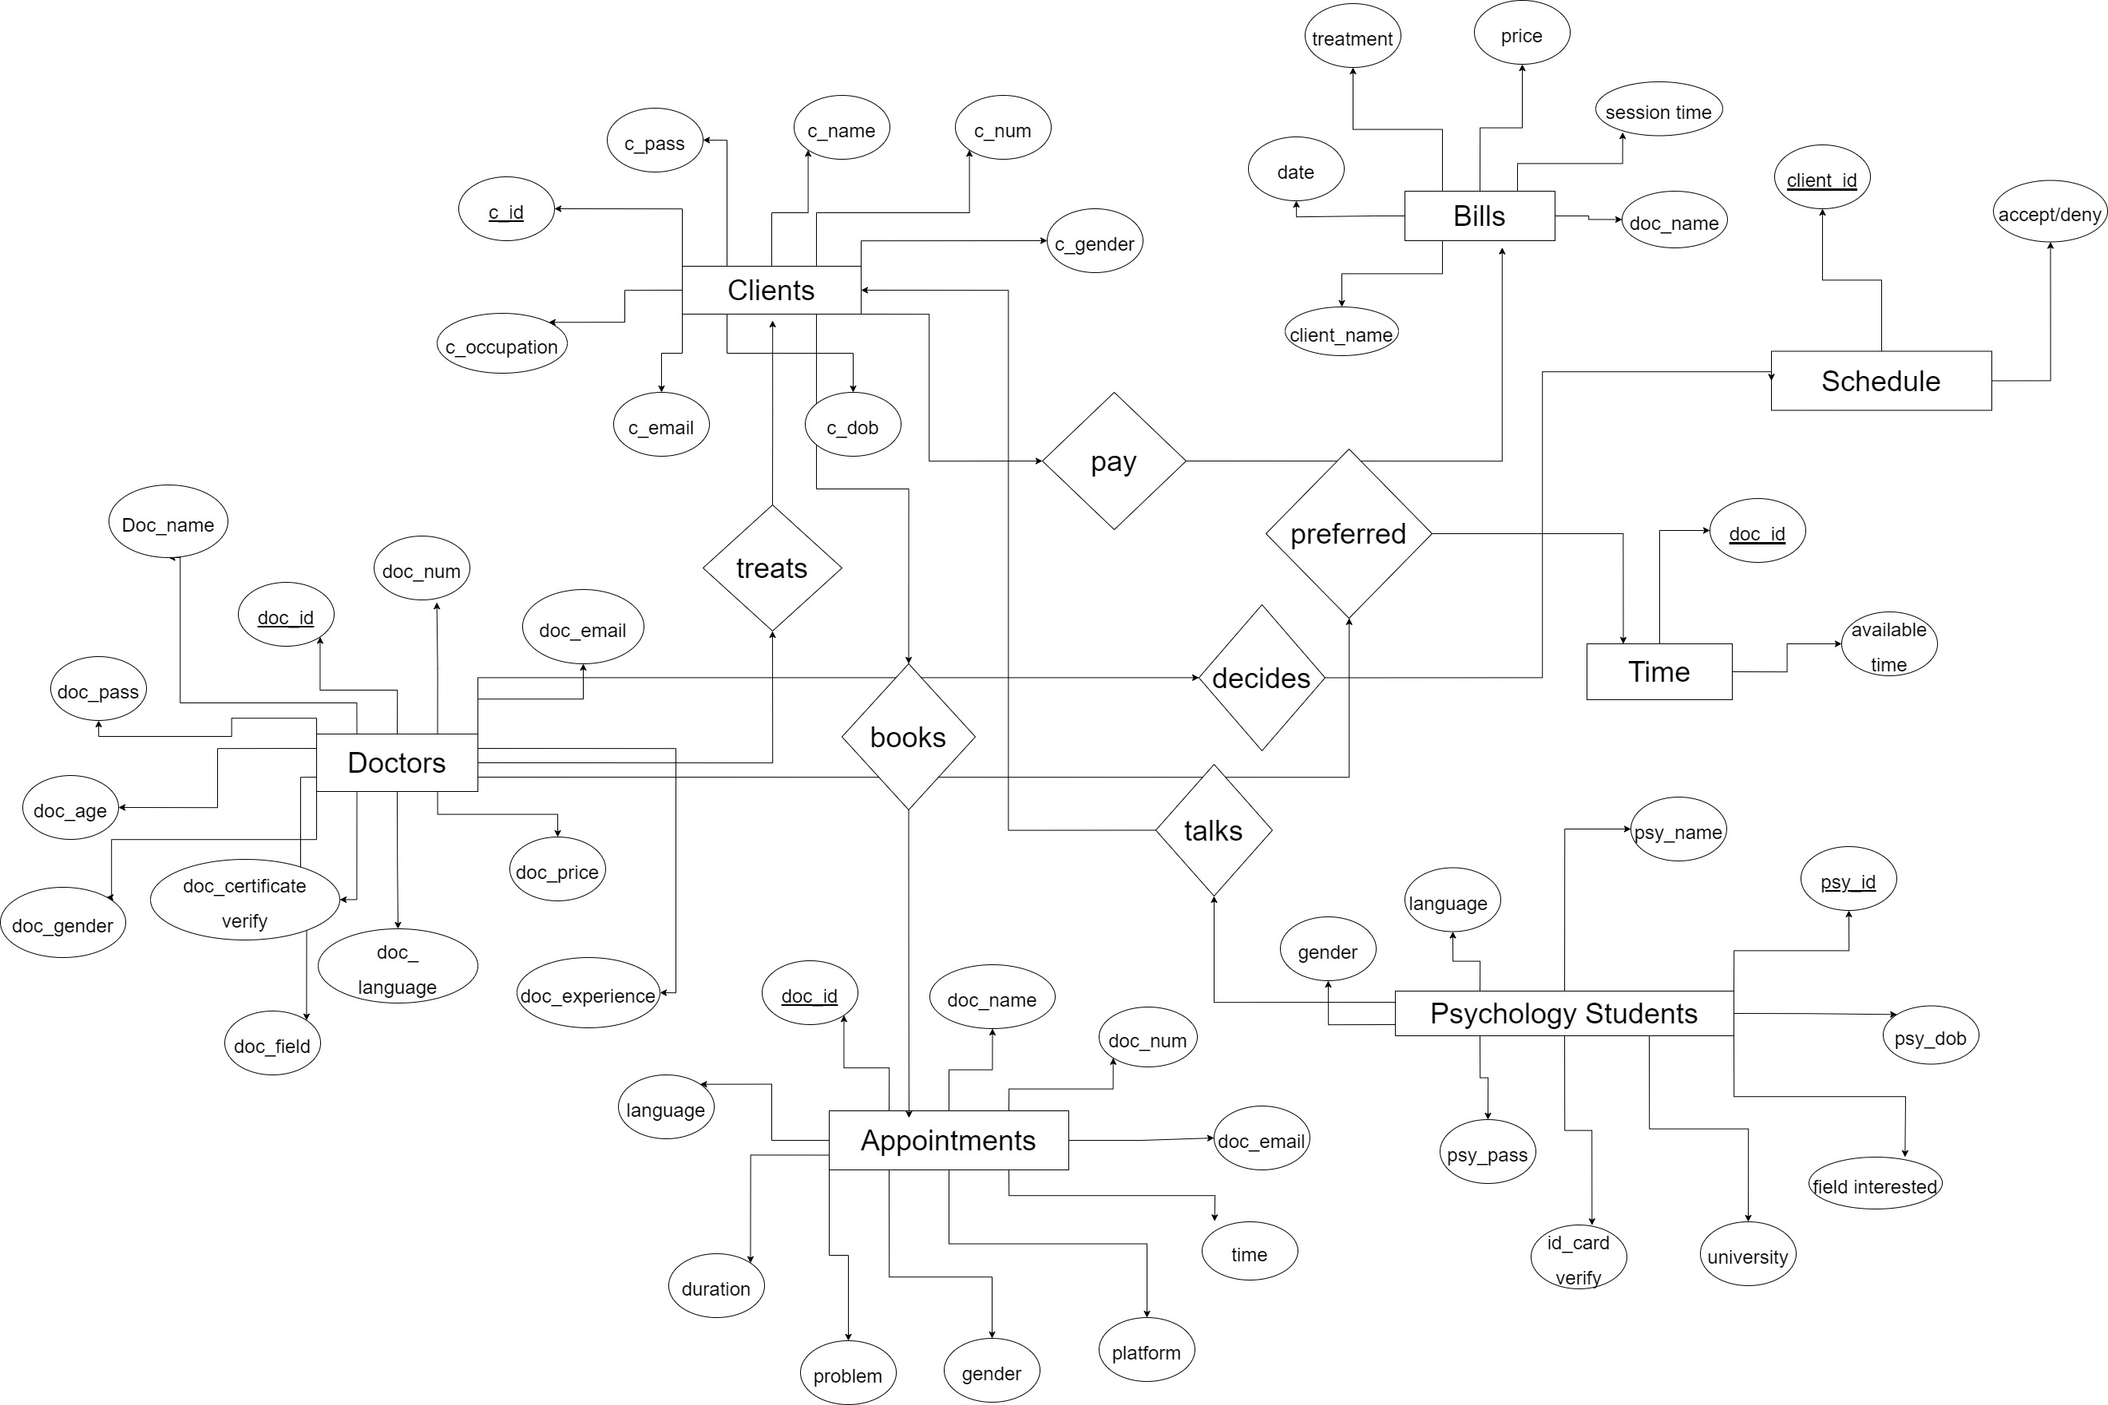







**Fig 3**

**3.3 DATA FLOW DIAGRAM**

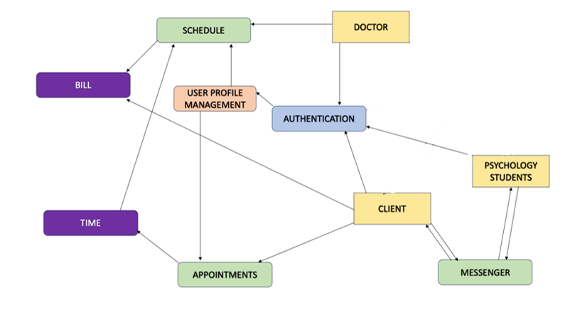

**Fig 2**

**3.4 PERT CHART**

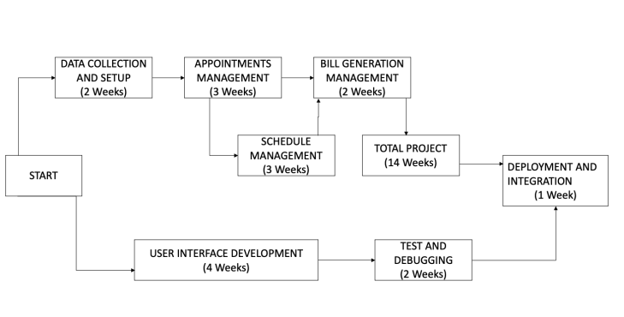

**Fig 3**

**3.5 GANTT CHART**

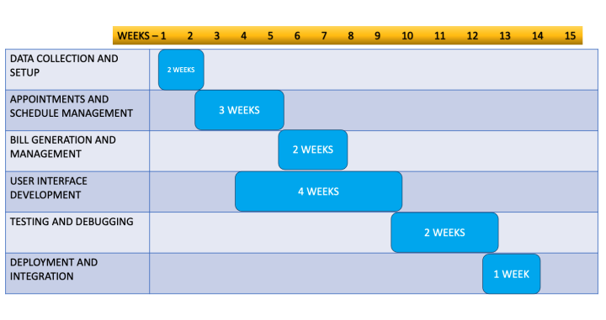

**Fig 4**

1. **IMPLEMENTATION**

**4.1 SOURCE CODE**

**Splash screen**

import '/flutter_flow/flutter_flow_animations.dart';

import '/flutter_flow/flutter_flow_icon_button.dart';

import '/flutter_flow/flutter_flow_theme.dart';

import '/flutter_flow/flutter_flow_util.dart';

import '/flutter_flow/flutter_flow_widgets.dart';

import 'package:flutter/material.dart';

import 'package:flutter/scheduler.dart';

import 'package:flutter/services.dart';

import 'package:flutter_animate/flutter_animate.dart';

import 'package:google_fonts/google_fonts.dart';

import 'package:provider/provider.dart';

import 'splash_screen_model.dart';

export 'splash_screen_model.dart';

class SplashScreenWidget extends StatefulWidget {

const SplashScreenWidget({Key? key}) : super(key: key);

@override

_SplashScreenWidgetState createState() => _SplashScreenWidgetState();

}

class _SplashScreenWidgetState extends State<SplashScreenWidget>

with TickerProviderStateMixin {

late SplashScreenModel _model;

final scaffoldKey = GlobalKey<ScaffoldState>();

final animationsMap = {

'buttonOnPageLoadAnimation1': AnimationInfo(

trigger: AnimationTrigger.onPageLoad,

effects: [

FadeEffect(

curve: Curves.easeInOut,

delay: 250.ms,

duration: 600.ms,

begin: 0,

end: 1,

),

MoveEffect(

curve: Curves.easeInOut,

delay: 250.ms,

duration: 600.ms,

begin: Offset(0, 64),

end: Offset(0, 0),

),

ScaleEffect(

curve: Curves.easeInOut,

delay: 250.ms,

duration: 600.ms,

begin: Offset(1, 0),

end: Offset(1, 1),

),

],

),

'buttonOnPageLoadAnimation2': AnimationInfo(

trigger: AnimationTrigger.onPageLoad,

effects: [

FadeEffect(

curve: Curves.easeInOut,

delay: 250.ms,

duration: 600.ms,

begin: 0,

end: 1,

),

MoveEffect(

curve: Curves.easeInOut,

delay: 250.ms,

duration: 600.ms,

begin: Offset(0, 64),

end: Offset(0, 0),

),

ScaleEffect(

curve: Curves.easeInOut,

delay: 250.ms,

duration: 600.ms,

begin: Offset(1, 0),

end: Offset(1, 1),

),

],

),

'buttonOnPageLoadAnimation3': AnimationInfo(

trigger: AnimationTrigger.onPageLoad,

effects: [

FadeEffect(

curve: Curves.easeInOut,

delay: 250.ms,

duration: 600.ms,

begin: 0,

end: 1,

),

),

],

),

};

@override

void initState() {

super.initState();

_model = createModel(context, () => SplashScreenModel());

setupAnimations(

animationsMap.values.where((anim) =>

anim.trigger == AnimationTrigger.onActionTrigger ||

!anim.applyInitialState),

this,

);

}

@override

void dispose() {

_model.dispose();

super.dispose();

}

@override

Widget build(BuildContext context) {

if (isiOS) {

SystemChrome.setSystemUIOverlayStyle(

SystemUiOverlayStyle(

statusBarBrightness: Theme.of(context).brightness,

systemStatusBarContrastEnforced: true,

),

);

}

return Scaffold(

key: scaffoldKey,

backgroundColor: FlutterFlowTheme.of(context).primaryBlack,

body: Stack(

children: [

Container(

width: MediaQuery.sizeOf(context).width * 1.303,

height: MediaQuery.sizeOf(context).height * 1,

decoration: BoxDecoration(

color: Color(0x007CF0FF),

image: DecorationImage(

fit: BoxFit.fill,

image: Image.asset(

'assets/images/Artboard_1.png',

).image, animationsMap['buttonOnPageLoadAnimation2']!),

),

Padding(

padding:

EdgeInsetsDirectional.fromSTEB(10, 10, 10, 10),

child: FFButtonWidget(

onPressed: () async {

context.pushNamed(

'PsychologySignUp',

extra: <String, dynamic>{

kTransitionInfoKey: TransitionInfo(

hasTransition: true,

transitionType: PageTransitionType.fade,

duration: Duration(milliseconds: 6),

),

},

);

},

.override(

fontFamily: 'Outfit',

color: FlutterFlowTheme.of(context)

.primaryBtnText,

fontWeight: FontWeight.bold,

),

elevation: 3,

borderSide: BorderSide(

color: Colors.transparent,

width: 1,

),

borderRadius: BorderRadius.circular(8),

),

).animateOnPageLoad(

animationsMap['buttonOnPageLoadAnimation3']!),

),

Padding(

),

},

);

},

),

elevation: 3,

borderSide: BorderSide(

color: Colors.transparent,

width: 1,

),

borderRadius: BorderRadius.circular(8),

),

).animateOnPageLoad(

animationsMap['buttonOnPageLoadAnimation4']!),

),

],

),

),

Align(

alignment: AlignmentDirectional(0.95, -0.99),

child: FlutterFlowIconButton(

borderColor: Color(0x00FFFFFF),

borderRadius: 20,

buttonSize: 40,

fillColor: Color(0x00616161),

icon: Icon(

Icons.info_outline_rounded,

color: FlutterFlowTheme.of(context).primaryBtnText,

size: 35,

),

onPressed: () async {

context.pushNamed('AboutUs');

},

),

),

],

),

),

],

),

);

}

}

**About us**

import '/flutter_flow/flutter_flow_animations.dart';

import '/flutter_flow/flutter_flow_icon_button.dart';

import '/flutter_flow/flutter_flow_theme.dart';

import '/flutter_flow/flutter_flow_util.dart';

import '/flutter_flow/flutter_flow_widgets.dart';

import 'dart:ui';

import 'package:smooth_page_indicator/smooth_page_indicator.dart'

as smooth_page_indicator;

import 'package:flutter/material.dart';

import 'package:flutter/scheduler.dart';

import 'package:flutter/services.dart';

import 'package:flutter_animate/flutter_animate.dart';

import 'package:google_fonts/google_fonts.dart';

import 'package:provider/provider.dart';

import 'about_us_model.dart';

export 'about_us_model.dart';

class AboutUsWidget extends StatefulWidget {

const AboutUsWidget({Key? key}) : super(key: key);

@override

_AboutUsWidgetState createState() => _AboutUsWidgetState();

}

class _AboutUsWidgetState extends State<AboutUsWidget>

with TickerProviderStateMixin {

late AboutUsModel _model;

final scaffoldKey = GlobalKey<ScaffoldState>();

final animationsMap = {

'imageOnPageLoadAnimation1': AnimationInfo(

trigger: AnimationTrigger.onPageLoad,

effects: [

FadeEffect(

curve: Curves.easeInOut,

delay: 0.ms,

duration: 600.ms,

begin: 0,

end: 1,

),

ScaleEffect(

curve: Curves.easeInOut,

delay: 0.ms,

duration: 600.ms,

begin: Offset(1.2, 1.2),

end: Offset(1, 1),

),

],

),

'textOnPageLoadAnimation1': AnimationInfo(

trigger: AnimationTrigger.onPageLoad,

effects: [

FadeEffect(

curve: Curves.easeInOut,

delay: 0.ms,

duration: 600.ms,

begin: 0,

end: 1,

),

MoveEffect(

curve: Curves.easeInOut,

delay: 0.ms,

duration: 600.ms,

begin: Offset(0, 60),

end: Offset(0, 0),

),

],

),

'textOnPageLoadAnimation2': AnimationInfo(

trigger: AnimationTrigger.onPageLoad,

effects: [

FadeEffect(

curve: Curves.easeInOut,

delay: 0.ms,

duration: 600.ms,

begin: 0,

end: 1,

),

MoveEffect(

curve: Curves.easeInOut,

delay: 0.ms,

duration: 600.ms,

begin: Offset(0, 80),

end: Offset(0, 0),

),

],

),

'iconButtonOnPageLoadAnimation1': AnimationInfo(

trigger: AnimationTrigger.onPageLoad,

effects: [

FadeEffect(

),

],

),

'textOnPageLoadAnimation3': AnimationInfo(

trigger: AnimationTrigger.onPageLoad,

effects: [

),

),

!anim.applyInitialState),

this,

);

}

@override

void dispose() {

_model.dispose();

super.dispose();

}

@override

Widget build(BuildContext context) {

if (isiOS) {

SystemChrome.setSystemUIOverlayStyle(

SystemUiOverlayStyle(

statusBarBrightness: Theme.of(context).brightness,

systemStatusBarContrastEnforced: true,

),

);

}

return GestureDetector(

onTap: () => _model.unfocusNode.canRequestFocus

? FocusScope.of(context).requestFocus(_model.unfocusNode)

: FocusScope.of(context).unfocus(),

child: Scaffold(

key: scaffoldKey,

backgroundColor: FlutterFlowTheme.of(context).primaryBackground,

body: Container(

width: double.infinity,

height: double.infinity,

child: Stack(

children: [

PageView(

controller: _model.pageViewController ??=

PageController(initialPage: 0),

scrollDirection: Axis.horizontal,

children: [

Column(

mainAxisSize: MainAxisSize.max,

children: [

Image.asset(

'assets/images/7e3e717fde43d92d24baaa6861ed28bb.jpg',

width: double.infinity,

height: 484,

fit: BoxFit.cover,

).animateOnPageLoad(

animationsMap['imageOnPageLoadAnimation1']!),

Padding(

padding: EdgeInsetsDirectional.fromSTEB(24, 24, 24, 24),

child: Column(

mainAxisSize: MainAxisSize.max,

crossAxisAlignment: CrossAxisAlignment.start,

children: [

Text(

'ABOUT HEY DOC !',

style:

FlutterFlowTheme.of(context).headlineMedium,

).animateOnPageLoad(

animationsMap['textOnPageLoadAnimation1']!),

Padding(

padding:

EdgeInsetsDirectional.fromSTEB(0, 12, 0, 0),

child: Text(

'Welcome to Hey Doc - your dedicated companion on your journey to mental well-being and emotional empowerment. Our app is more than just a platform; it\'s a safe haven where you can find solace, guidance, and transformation. At Hey Doc, we understand that mental health is a cornerstone of overall wellness, and seeking therapy is a significant step towards a happier, healthier you',

style: FlutterFlowTheme.of(context).labelMedium,

).animateOnPageLoad(

animationsMap['textOnPageLoadAnimation2']!),

),

Padding(

padding:

EdgeInsetsDirectional.fromSTEB(0, 24, 0, 0),

child: Row(

mainAxisSize: MainAxisSize.max,

mainAxisAlignment: MainAxisAlignment.end,

children: [

FlutterFlowIconButton(

).animateOnPageLoad(animationsMap[

'buttonOnPageLoadAnimation']!),

),

],

),

),

),

),

).animateOnPageLoad(

animationsMap['containerOnPageLoadAnimation']!),

],

),

Align(

alignment: AlignmentDirectional(-0.85, 0.85),

child: Padding(

padding: EdgeInsetsDirectional.fromSTEB(0, 0, 0, 10),

child: smooth_page_indicator.SmoothPageIndicator(

controller: _model.pageViewController ??=

PageController(initialPage: 0),

count: 3,

axisDirection: Axis.horizontal,

},

effect: smooth_page_indicator.ExpandingDotsEffect(

expansionFactor: 2,

spacing: 8,

radius: 16,

dotWidth: 16,

dotHeight: 4,

dotColor: FlutterFlowTheme.of(context).accent1,

activeDotColor: FlutterFlowTheme.of(context).primary,

paintStyle: PaintingStyle.fill,

),

),

),

),

],

),

),

),

);

}

}

**Login Page:**

import '/auth/firebase_auth/auth_util.dart';

import '/backend/backend.dart';

import '/flutter_flow/flutter_flow_drop_down.dart';

import '/flutter_flow/flutter_flow_icon_button.dart';

import '/flutter_flow/flutter_flow_theme.dart';

import '/flutter_flow/flutter_flow_util.dart';

import '/flutter_flow/flutter_flow_widgets.dart';

import '/flutter_flow/form_field_controller.dart';

import 'package:flutter/material.dart';

import 'package:flutter/services.dart';

import 'package:google_fonts/google_fonts.dart';

import 'package:provider/provider.dart';

import 'login_page_model.dart';

export 'login_page_model.dart';

class LoginPageWidget extends StatefulWidget {

const LoginPageWidget({Key? key}) : super(key: key);

@override

_LoginPageWidgetState createState() => _LoginPageWidgetState();

}

class _LoginPageWidgetState extends State<LoginPageWidget> {

late LoginPageModel _model;

final scaffoldKey = GlobalKey<ScaffoldState>();

@override

void initState() {

super.initState();

_model = createModel(context, () => LoginPageModel());

_model.emailAddressLoginController ??= TextEditingController();

_model.emailAddressLoginFocusNode ??= FocusNode();

_model.passwordLoginController ??= TextEditingController();

_model.passwordLoginFocusNode ??= FocusNode();

}

@override

void dispose() {

_model.dispose();

super.dispose();

}

@override

Widget build(BuildContext context) {

if (isiOS) {

SystemChrome.setSystemUIOverlayStyle(

SystemUiOverlayStyle(

statusBarBrightness: Theme.of(context).brightness,

systemStatusBarContrastEnforced: true,

),

);

}

return GestureDetector(

onTap: () => _model.unfocusNode.canRequestFocus

? FocusScope.of(context).requestFocus(_model.unfocusNode)

: FocusScope.of(context).unfocus(),

child: Scaffold(

key: scaffoldKey,

backgroundColor: Color(0xFF14181B),

body: Container(

width: MediaQuery.sizeOf(context).width,

height: MediaQuery.sizeOf(context).height * 1,

decoration: BoxDecoration(

color: Color(0xFF14181B),

),

child: Container(

width: 100,

height: 100,

decoration: BoxDecoration(

color: Color(0x990F1113),

image: DecorationImage(

fit: BoxFit.cover,

image: Image.asset(

'assets/images/Cartoon_Wallpaper.jpg',

).image,

),

),

child: Stack(

children: [

Padding(

padding: EdgeInsetsDirectional.fromSTEB(0, 70, 0, 0),

child: Column(

mainAxisSize: MainAxisSize.max,

children: [

Padding(

padding: EdgeInsetsDirectional.fromSTEB(0, 16, 0, 20),

child: Row(

mainAxisSize: MainAxisSize.max,

mainAxisAlignment: MainAxisAlignment.center,

children: [

Padding(

padding:

EdgeInsetsDirectional.fromSTEB(20, 0, 0, 0),

child: Image.asset(

'assets/images/Screenshot_2023-08-31_092119-removebg-preview.png',

width: 167,

height: 128,

fit: BoxFit.cover,

),

),

],

),

),

Padding(

padding: EdgeInsetsDirectional.fromSTEB(44, 50, 44, 0),

child: StreamBuilder<List<AuthSigninRecord>>(

stream: queryAuthSigninRecord(

queryBuilder: (authSigninRecord) =>

authSigninRecord.where(

'email',

isEqualTo:

_model.emailAddressLoginController.text,

),

singleRecord: true,

),

builder: (context, snapshot) {

// Customize what your widget looks like when it's loading.

if (!snapshot.hasData) {

return Center(

child: SizedBox(

width: 50,

height: 50,

child: CircularProgressIndicator(

valueColor: AlwaysStoppedAnimation<Color>(

FlutterFlowTheme.of(context).primary,

: false) {

if (_model

.override(

fontFamily: 'Outfit',

color:

FlutterFlowTheme.of(context)

.white,

),

elevation: 0,

borderSide: BorderSide(

color: Colors.transparent,

},

),

),

],

),

),

Padding(

padding: EdgeInsetsDirectional.fromSTEB(30, 30, 30, 30),

child: FlutterFlowIconButton(

borderColor: Color(0x0442BEA5),

borderRadius: 20,

borderWidth: 1,

buttonSize: 40,

fillColor: Color(0x00616161),

icon: Icon(

Icons.arrow_back_ios,

color: Color(0xD4010000),

size: 24,

),

onPressed: () async {

context.pushNamed('SplashScreen');

},

),

),

],

),

),

),

),

);

}

}

**Doctor profile :**

import '/backend/backend.dart';

import '/flutter_flow/flutter_flow_icon_button.dart';

import '/flutter_flow/flutter_flow_theme.dart';

import '/flutter_flow/flutter_flow_util.dart';

import '/flutter_flow/flutter_flow_widgets.dart';

import '/zz_c_o_m_p_o_n_e_n_t_s/user_nav_bar/user_nav_bar_main/user_nav_bar_main_widget.dart';

import 'package:flutter/material.dart';

import 'package:flutter/services.dart';

import 'package:flutter_rating_bar/flutter_rating_bar.dart';

import 'package:google_fonts/google_fonts.dart';

import 'package:provider/provider.dart';

import 'profile_doctor_model.dart';

export 'profile_doctor_model.dart';

class ProfileDoctorWidget extends StatefulWidget {

const ProfileDoctorWidget({

Key? key,

required this.doctorname,

required this.doctorspec,

required this.doctormail,

required this.date,

required this.userprof,

}) : super(key: key);

final String? doctorname;

final String? doctorspec;

final String? doctormail;

final String? date;

final String? userprof;

@override

_ProfileDoctorWidgetState createState() => _ProfileDoctorWidgetState();

}

class _ProfileDoctorWidgetState extends State<ProfileDoctorWidget> {

late ProfileDoctorModel _model;

final scaffoldKey = GlobalKey<ScaffoldState>();

@override

void initState() {

super.initState();

_model = createModel(context, () => ProfileDoctorModel());

}

@override

void dispose() {

_model.dispose();

super.dispose();

}

@override

Widget build(BuildContext context) {

if (isiOS) {

SystemChrome.setSystemUIOverlayStyle(

SystemUiOverlayStyle(

statusBarBrightness: Theme.of(context).brightness,

systemStatusBarContrastEnforced: true,

),

);

}

return GestureDetector(

onTap: () => _model.unfocusNode.canRequestFocus

? FocusScope.of(context).requestFocus(_model.unfocusNode)

: FocusScope.of(context).unfocus(),

child: Scaffold(

key: scaffoldKey,

backgroundColor: FlutterFlowTheme.of(context).primaryBackground,

appBar: AppBar(

backgroundColor: FlutterFlowTheme.of(context).primaryBlack,

automaticallyImplyLeading: false,

leading: FlutterFlowIconButton(

borderColor: Colors.transparent,

borderRadius: 30,

borderWidth: 1,

buttonSize: 60,

icon: Icon(

Icons.arrow_back_rounded,

color: FlutterFlowTheme.of(context).white,

size: 30,

),

onPressed: () async {

FlutterFlowTheme.of(context).warning,),

direction: Axis.horizontal,

initialRating: _model.ratingBarValue ??= 5,

unratedColor:

FlutterFlowTheme.of(context).alternate,

itemCount: 5,

itemSize: 24,

glowColor: FlutterFlowTheme.of(context).warning,),),

Padding(

padding: EdgeInsetsDirectional.fromSTEB(

0, 12, 0, 12),

widget.date,

ParamType.String,),

'userprof': serializeParam(

widget.userprof,

ParamType.String,), }.withoutNulls, ); },

text: 'Book Appointment',

options: FFButtonOptions(

width: double.infinity,

height: 48,

padding: EdgeInsetsDirectional.fromSTEB(

0, 0, 0, 0),

iconPadding:

EdgeInsetsDirectional.fromSTEB(

0, 0, 0, 0),

color: FlutterFlowTheme.of(context)

.primaryBlack,

textStyle: FlutterFlowTheme.of(context)

.titleSmall

.override(

fontFamily: 'Outfit',

color: Colors.white,),

borderSide: BorderSide(

color: Colors.transparent,

width: 1, ),

borderRadius: BorderRadius.circular(8),), ),),

Padding(

padding: EdgeInsetsDirectional.fromSTEB(

0, 0, 0, 12),

child: FFButtonWidget(

onPressed: () {

print('Button pressed ...'); },

text: 'Favorite Doctor',

**Doctor Home Page:**

import '/auth/firebase_auth/auth_util.dart';

import '/backend/backend.dart';

import '/flutter_flow/flutter_flow_calendar.dart';

import '/flutter_flow/flutter_flow_icon_button.dart';

import '/flutter_flow/flutter_flow_theme.dart';

import '/flutter_flow/flutter_flow_util.dart';

import '/flutter_flow/flutter_flow_widgets.dart';

import '/zz_c_o_m_p_o_n_e_n_t_s/doctor_nav_bar/doctor_nav_bar_main/doctor_nav_bar_main_widget.dart';

import 'dart:ui';

import 'package:cloud_firestore/cloud_firestore.dart';

import 'package:flutter/material.dart';

import 'package:flutter/services.dart';

import 'package:flutter_datetime_picker_plus/flutter_datetime_picker_plus.dart';

import 'package:google_fonts/google_fonts.dart';

import 'package:provider/provider.dart';

import 'package:share_plus/share_plus.dart';

import 'doctor_home_page_model.dart';

export 'doctor_home_page_model.dart';

class DoctorHomePageWidget extends StatefulWidget {

const DoctorHomePageWidget({Key? key}) : super(key: key);

@override

_DoctorHomePageWidgetState createState() => _DoctorHomePageWidgetState();

}

class _DoctorHomePageWidgetState extends State<DoctorHomePageWidget> {

late DoctorHomePageModel _model;

final scaffoldKey = GlobalKey<ScaffoldState>();

@override

void initState() {

super.initState();

_model = createModel(context, () => DoctorHomePageModel());

_model.textFieldFocusNode ??= FocusNode();

}

@override

void dispose() {

_model.dispose();

super.dispose();}

@override

Widget build(BuildContext context) {

if (isiOS) {

SystemChrome.setSystemUIOverlayStyle(

SystemUiOverlayStyle(

statusBarBrightness: Theme.of(context).brightness,

systemStatusBarContrastEnforced: true,),); }

return GestureDetector(

onTap: () => _model.unfocusNode.canRequestFocus

? FocusScope.of(context).requestFocus(_model.unfocusNode)

: FocusScope.of(context).unfocus(),

child: Scaffold(

key: scaffoldKey,

backgroundColor: Colors.white,

body: Stack(

children: [

SingleChildScrollView(

child: Column(

mainAxisSize: MainAxisSize.max,

children: [

Container(

width: double.infinity,

height: 500,

child: Stack(

alignment: AlignmentDirectional(0, -1),

children: [

Align(

alignment: AlignmentDirectional(0.00, -1.00),

child: Image.asset(

'assets/images/stable-diffusion-xl.jpeg',

width: double.infinity,

height: 500,

fit: BoxFit.cover,), ),

Align(

alignment: AlignmentDirectional(0.00, -1.00),

child: Padding(

padding:

EdgeInsetsDirectional.fromSTEB(16, 44, 16, 0),

child: Row(

mainAxisSize: MainAxisSize.max,

mainAxisAlignment: MainAxisAlignment.spaceBetween,

children: [

Container(

width: 40,

height: 40,

decoration: BoxDecoration(

color: Colors.white,

boxShadow: [

BoxShadow(

blurRadius: 4,

color: Color(0x520E151B),

offset: Offset(0, 2),)],

borderRadius: BorderRadius.circular(12),),

child: FlutterFlowIconButton(

borderColor: Colors.transparent,

borderRadius: 8,

borderWidth: 1,

buttonSize: 40,

fillColor: Colors.white,

icon: Icon(

Icons.arrow_back_rounded,

color: Color(0xFF57636C),

size: 20,),

onPressed: () async {

context.pop();}, ),),

Container(

width: 40,

height: 40,

decoration: BoxDecoration(

color: Colors.white,

boxShadow: [

BoxShadow(

blurRadius: 4,

color: Color(0x520E151B),

offset: Offset(0, 2),) ],

borderRadius: BorderRadius.circular(12),),

child: Builder(

builder: (context) => FlutterFlowIconButton(

borderColor: Colors.transparent,

borderRadius: 8,

borderWidth: 1,

buttonSize: 40,

fillColor: Colors.white,

icon: Icon(

Icons.info_outline,

color: Color(0xFF57636C),

size: 20,),

onPressed: () async {

await Share.share(

'',

sharePositionOrigin:

getWidgetBoundingBox(context), ); }, ),), ),], ),), ),

Align(

alignment: AlignmentDirectional(0.00, 1.00),

child: ClipRRect(

child: BackdropFilter(

filter: ImageFilter.blur(

sigmaX: 4,

sigmaY: 10,

),

child: InkWell(

splashColor: Colors.transparent,

focusColor: Colors.transparent,

hoverColor: Colors.transparent,

highlightColor: Colors.transparent,

onTap: () async {

await DatePicker.showDatePicker(

context,

showTitleActions: true,

onConfirm: (date) {

safeSetState(() {

_model.datePicked = date;

});

},

currentTime: getCurrentTimestamp,

minTime: getCurrentTimestamp,

maxTime: getCurrentTimestamp,); },

child: Container(

width: double.infinity,

height: 144,

decoration: BoxDecoration(

color: Color(0x801D2429),),

child: Stack(

children: [

Padding(

padding: EdgeInsetsDirectional.fromSTEB(

15, 0, 15, 0),

child: Column(

mainAxisSize: MainAxisSize.max,

mainAxisAlignment:

MainAxisAlignment.center,

children: [

Padding(

padding: EdgeInsetsDirectional

.fromSTEB(0, 8, 0, 0),

child: StreamBuilder<

List<DoctorSignupRecord>>(

stream: queryDoctorSignupRecord(

queryBuilder:

(doctorSignupRecord) =>

doctorSignupRecord

.where(

fontSize:

26,

fontWeight: FontWeight.normal,

), ),), ],), ],),],); },),),

Padding(

padding: EdgeInsetsDirectional

.fromSTEB(0, 4, 0, 0),

child: StreamBuilder<

List<DoctorSignupRecord>>(

stream: queryDoctorSignupRecord(

queryBuilder:

(doctorSignupRecord) =>

doctorSignupRecord

width: 50,

height: 50,

child:

CircularProgressIndicator(

valueColor:

AlwaysStoppedAnimation<

Color>(

FlutterFlowTheme.of(

context)

.primary,),), ),); }

List<DoctorSignupRecord>

rowDoctorSignupRecordList =

snapshot.data!;

// Return an empty Container when the item does not exist.

.primary,),),), ); }

List<DoctorSignupRecord>

columnDoctorSignupRecordList =

snapshot.data!;

// Return an empty Container when the item does not exist.

if (snapshot.data!.isEmpty) {

return Container();}

final columnDoctorSignupRecord =

columnDoctorSignupRecordList.isNotEmpty

? columnDoctorSignupRecordList.first

: null;

return Column(

mainAxisSize: MainAxisSize.max,

children: [

Padding(

padding: EdgeInsetsDirectional.fromSTEB(

10, 10, 10, 0),

child: Text(

'Kindly Add your Profile description (this will be visible to all users)',

style: FlutterFlowTheme.of(context)

.bodyMedium,),),

Padding(

newSelectedDate); },

titleStyle: FlutterFlowTheme.of(context)

.headlineSmall,

dayOfWeekStyle:

FlutterFlowTheme.of(context).labelLarge,

dateStyle:

FlutterFlowTheme.of(context).bodyMedium,

selectedDateStyle:

FlutterFlowTheme.of(context).titleSmall,

inactiveDateStyle:

FlutterFlowTheme.of(context)

.labelMedium,),],),),),),

Container(

width: 100,

height: 49,

decoration: BoxDecoration(

color: FlutterFlowTheme.of(context)

.secondaryBackground, ),),],),),], ),),

Align(

alignment: AlignmentDirectional(-0.36, 1.05),

child: Container(

width: 423,

height: 90,

decoration: BoxDecoration(

color: FlutterFlowTheme.of(context).secondaryBackground,),

child: wrapWithModel(

model: _model.doctorNavBarMainModel,

updateCallback: () => setState(() {}),

child: DoctorNavBarMainWidget(),

),),),],),),);}}

**4.2 SCREENSHOTS**

**SPLASH SCREEN, ABOUT US, AND LOGIN PAGE**

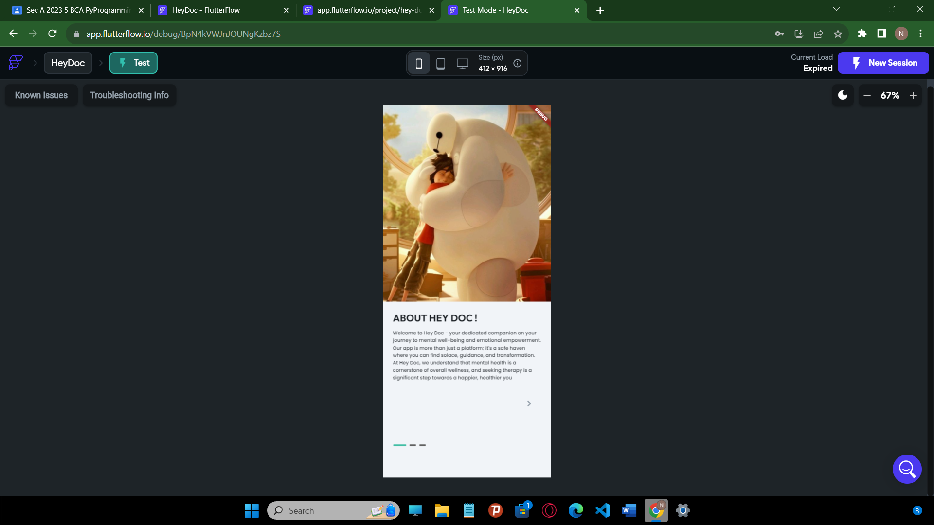 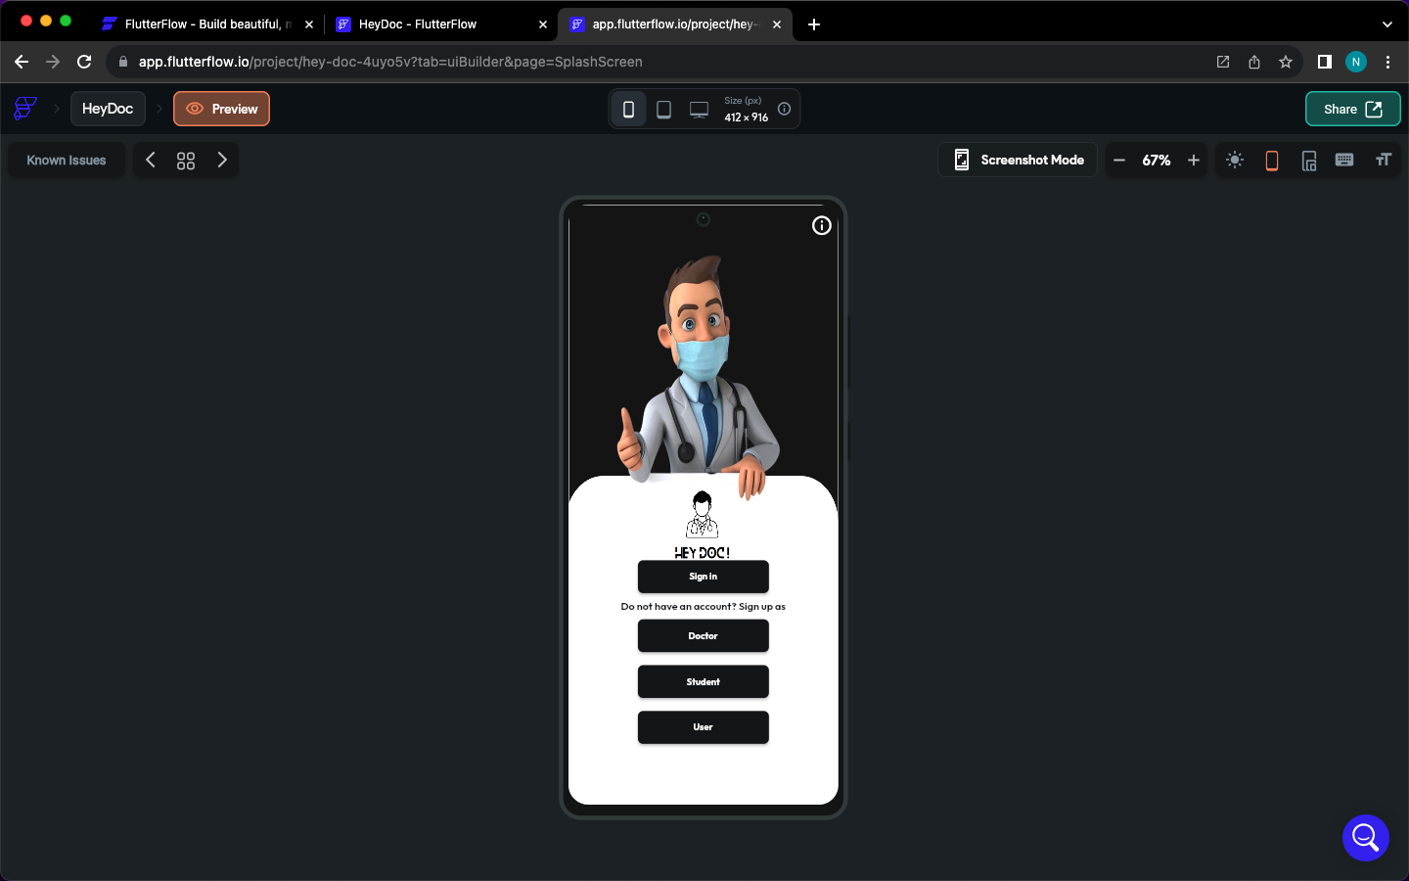 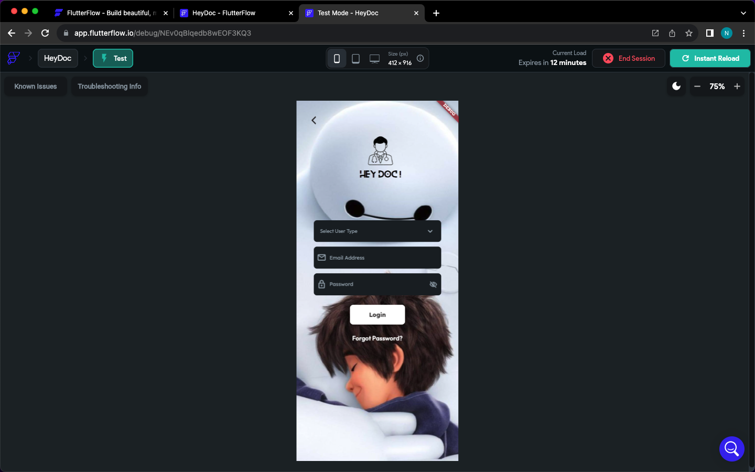

**SIGN UP PAGES - USER, DOCTOR, PSYCHOLOGY STUDENT**

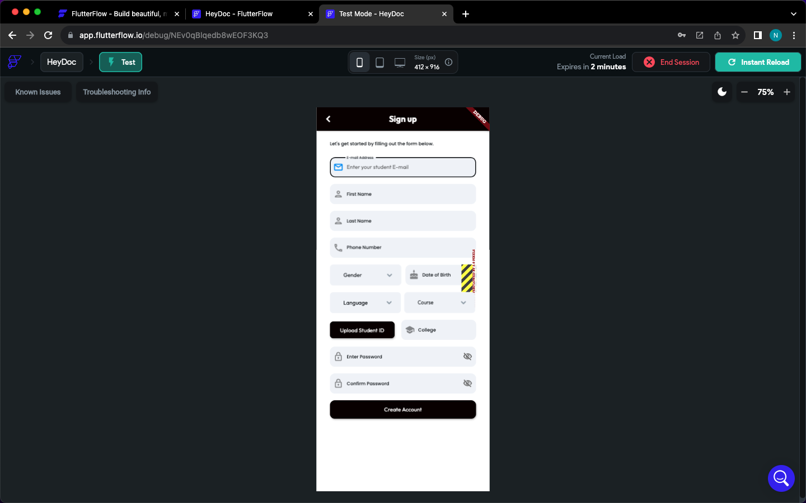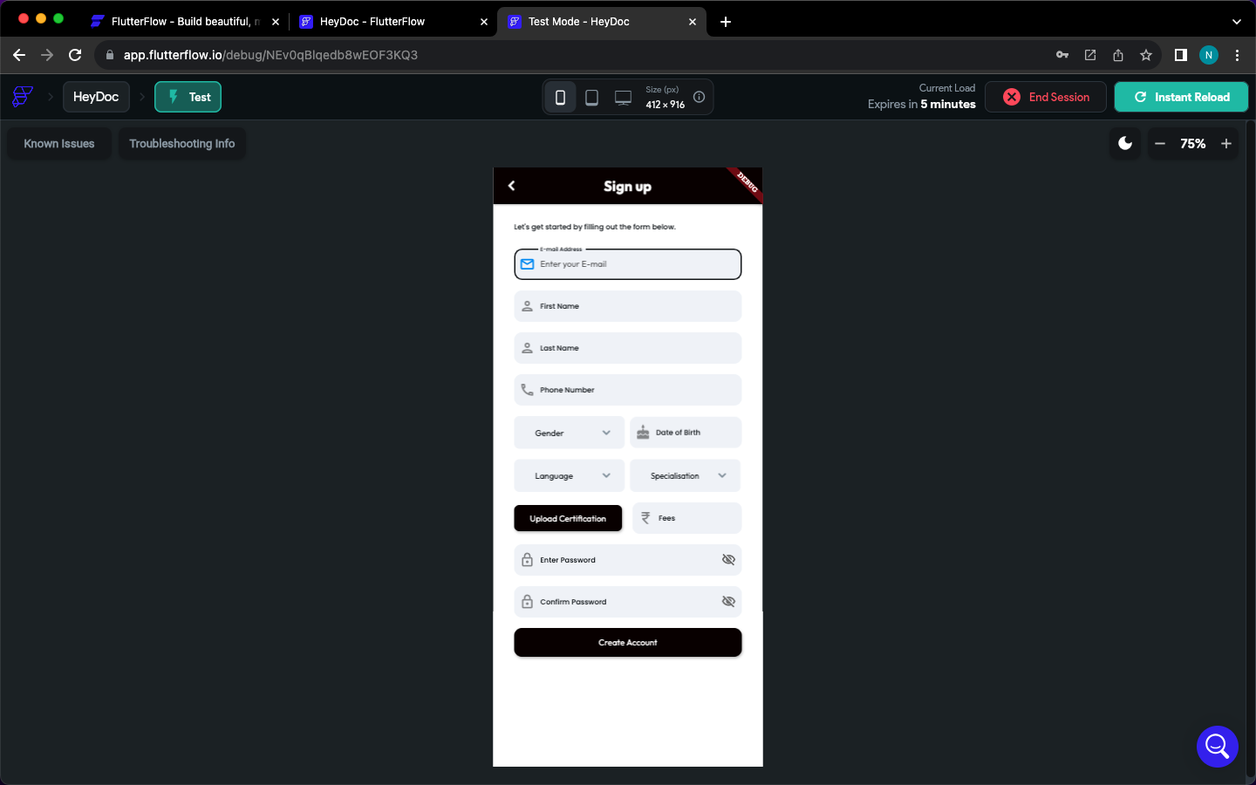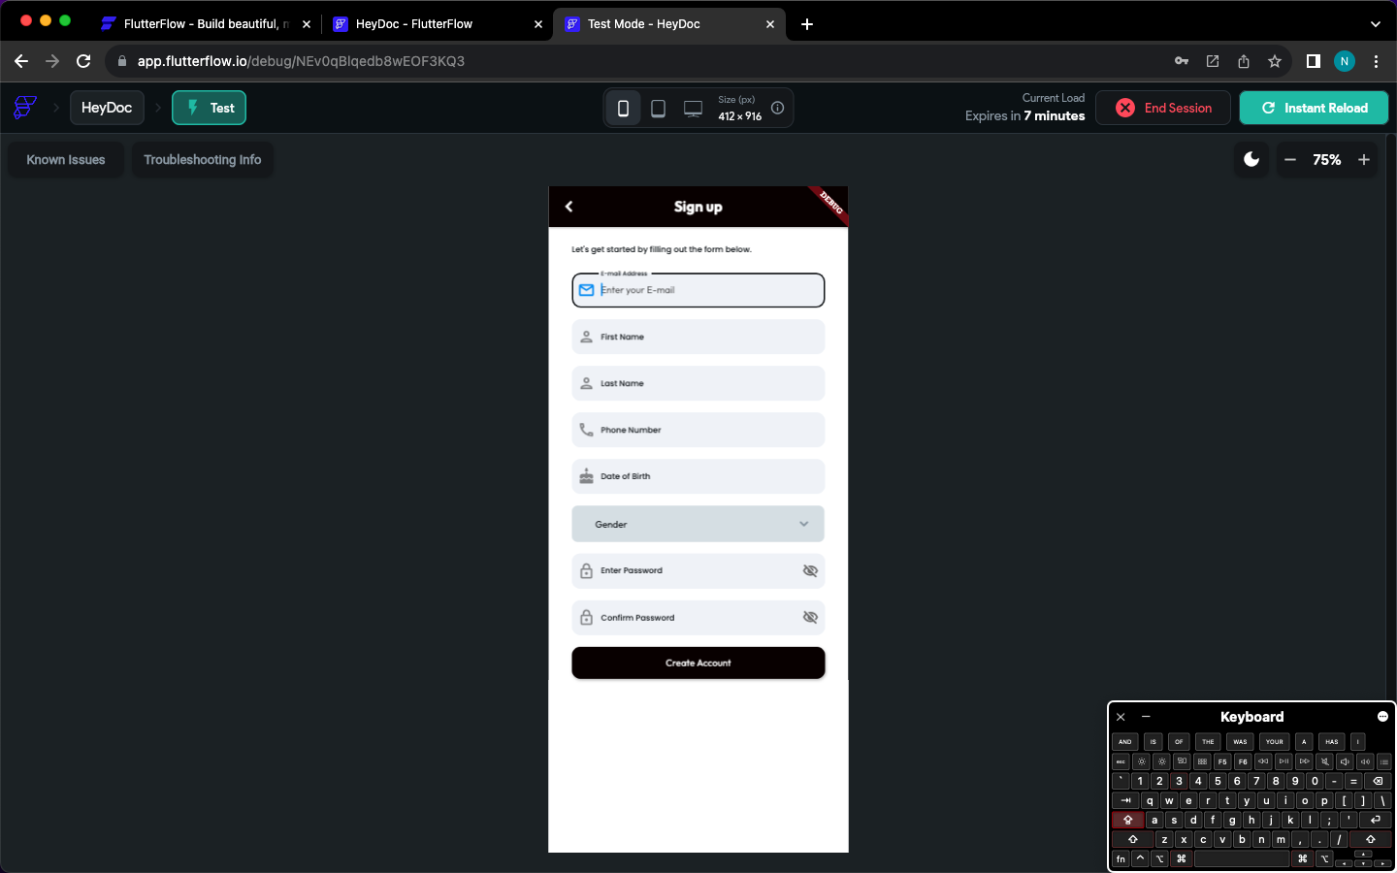

**HOME PAGES – USER, DOCTOR, PSYCHOLOGY STUDENT**

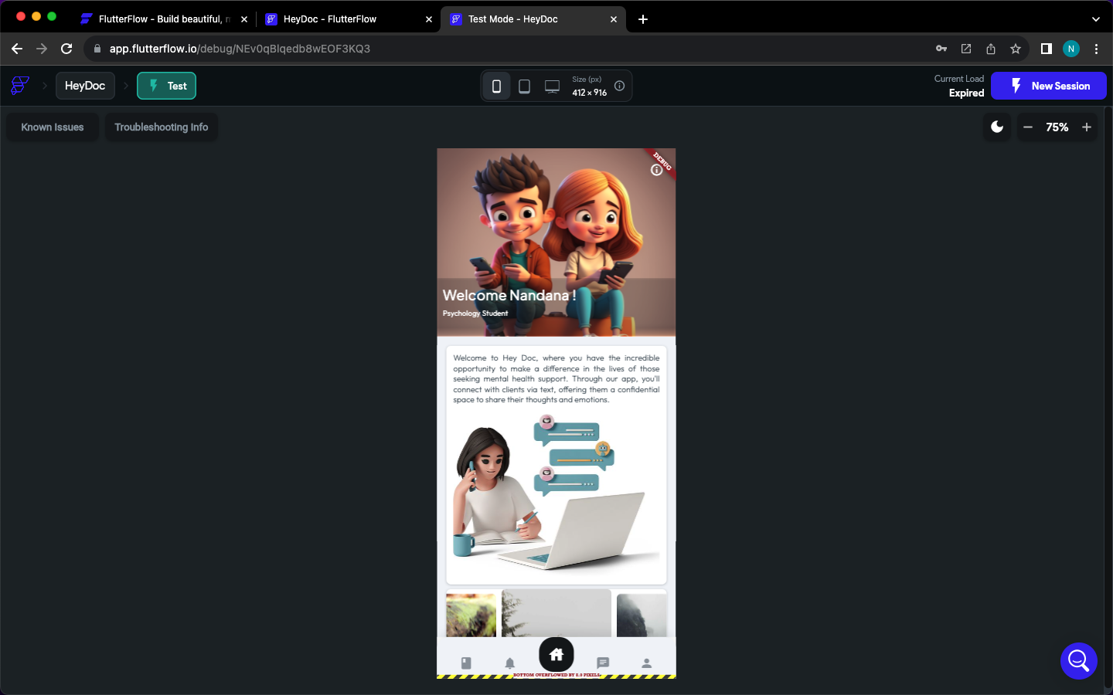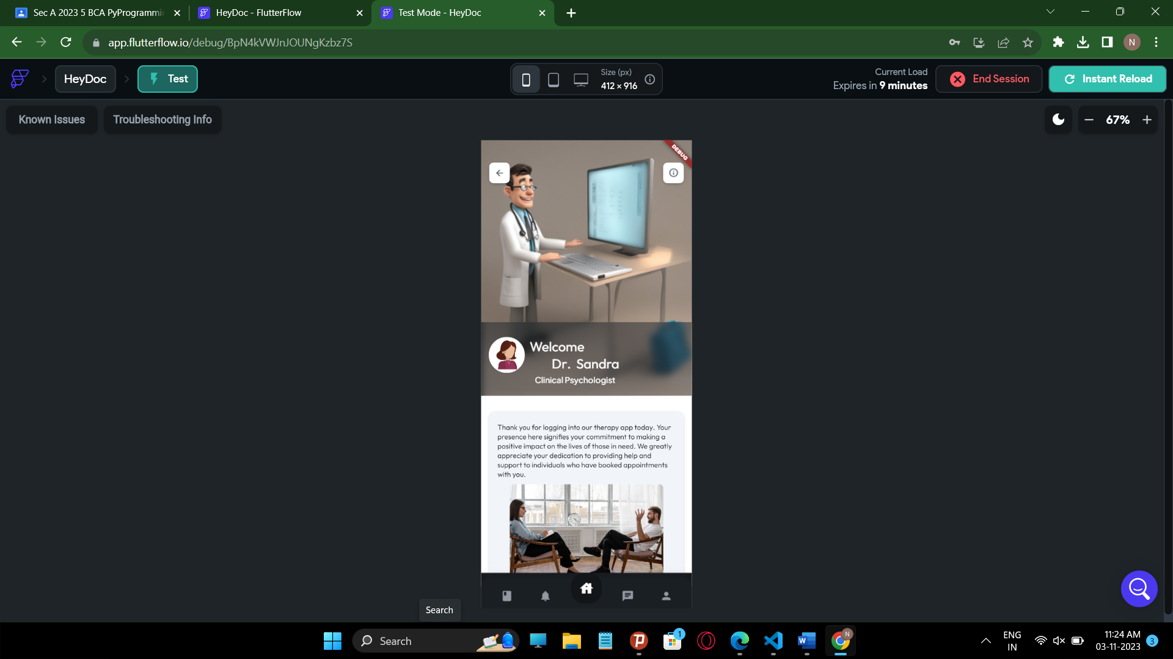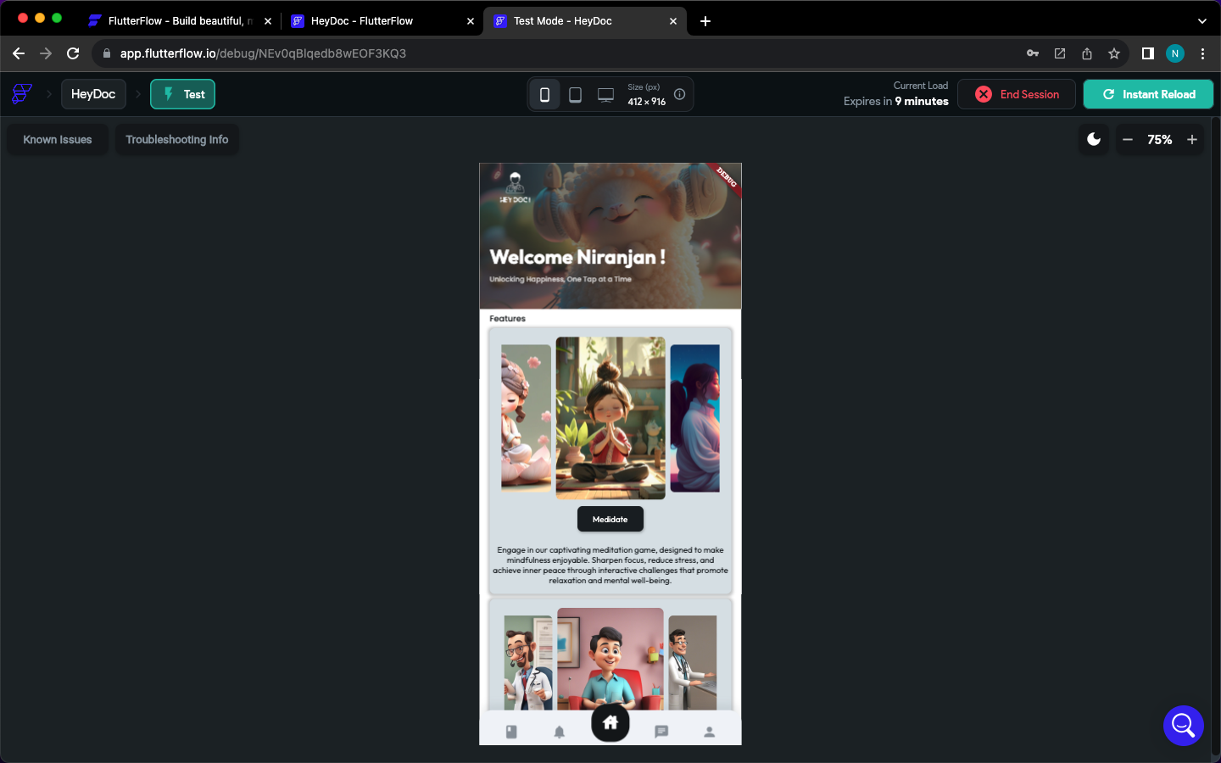

**PROFILE PAGES – USER, DOCTOR, PSYCHOLOGY STUDENT**

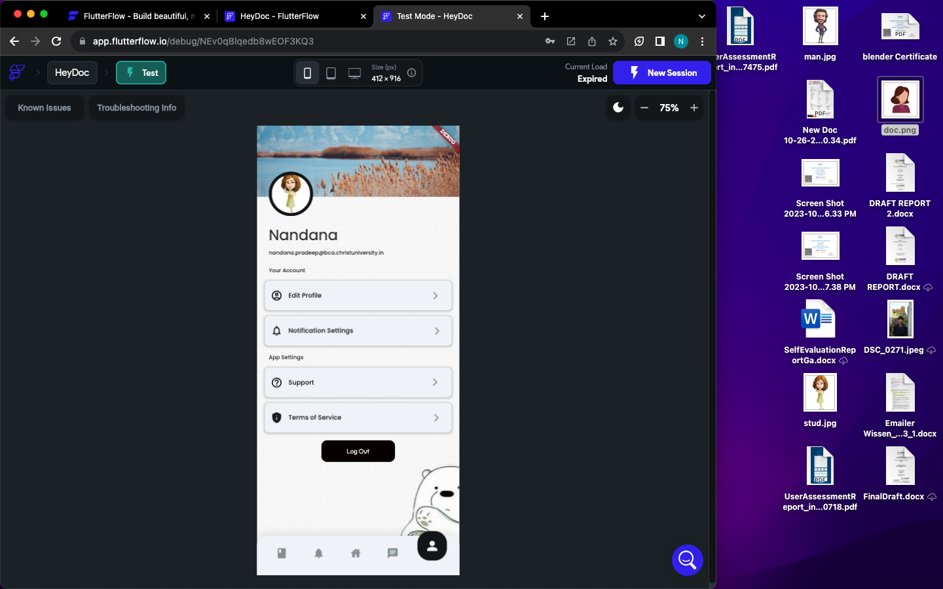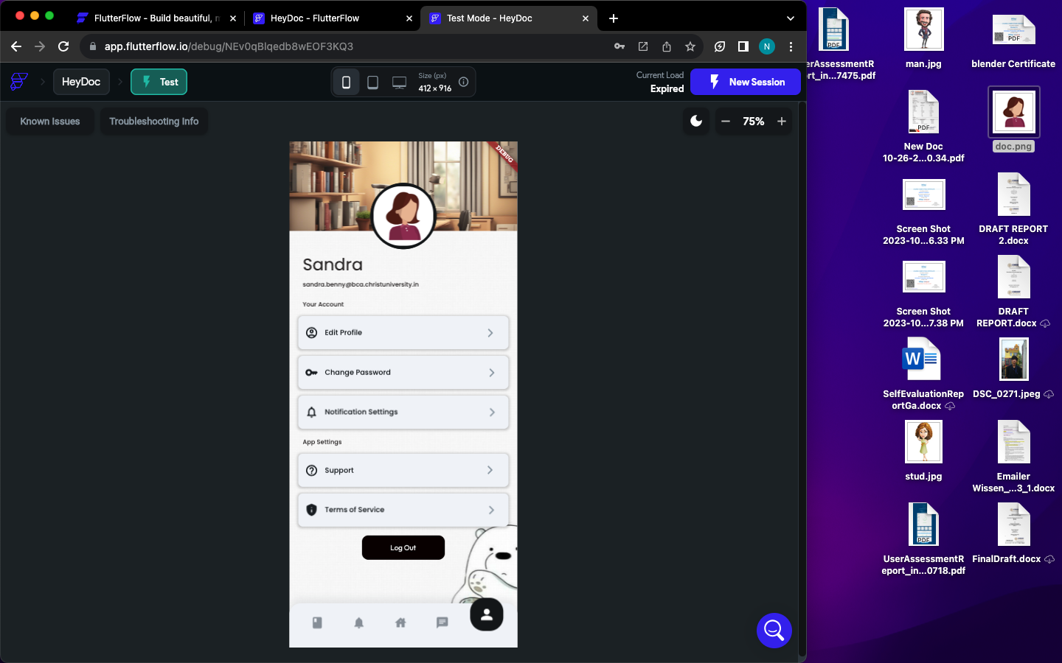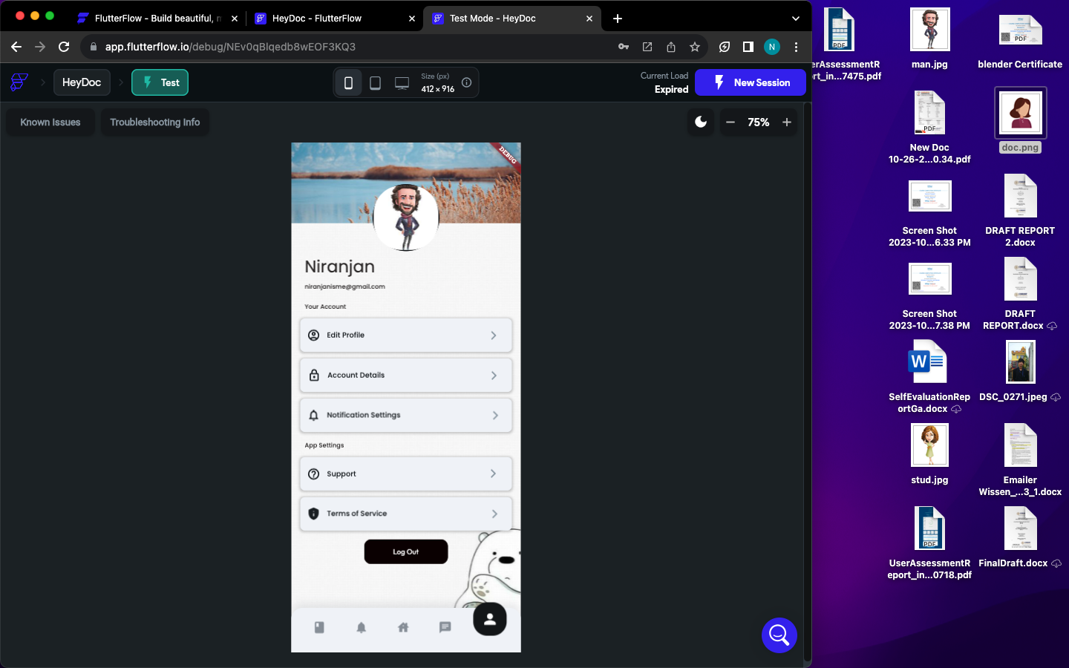

**EDIT PROFILE PAGES – USER, DOCTOR, PSYCHOLOGY STUDENT**

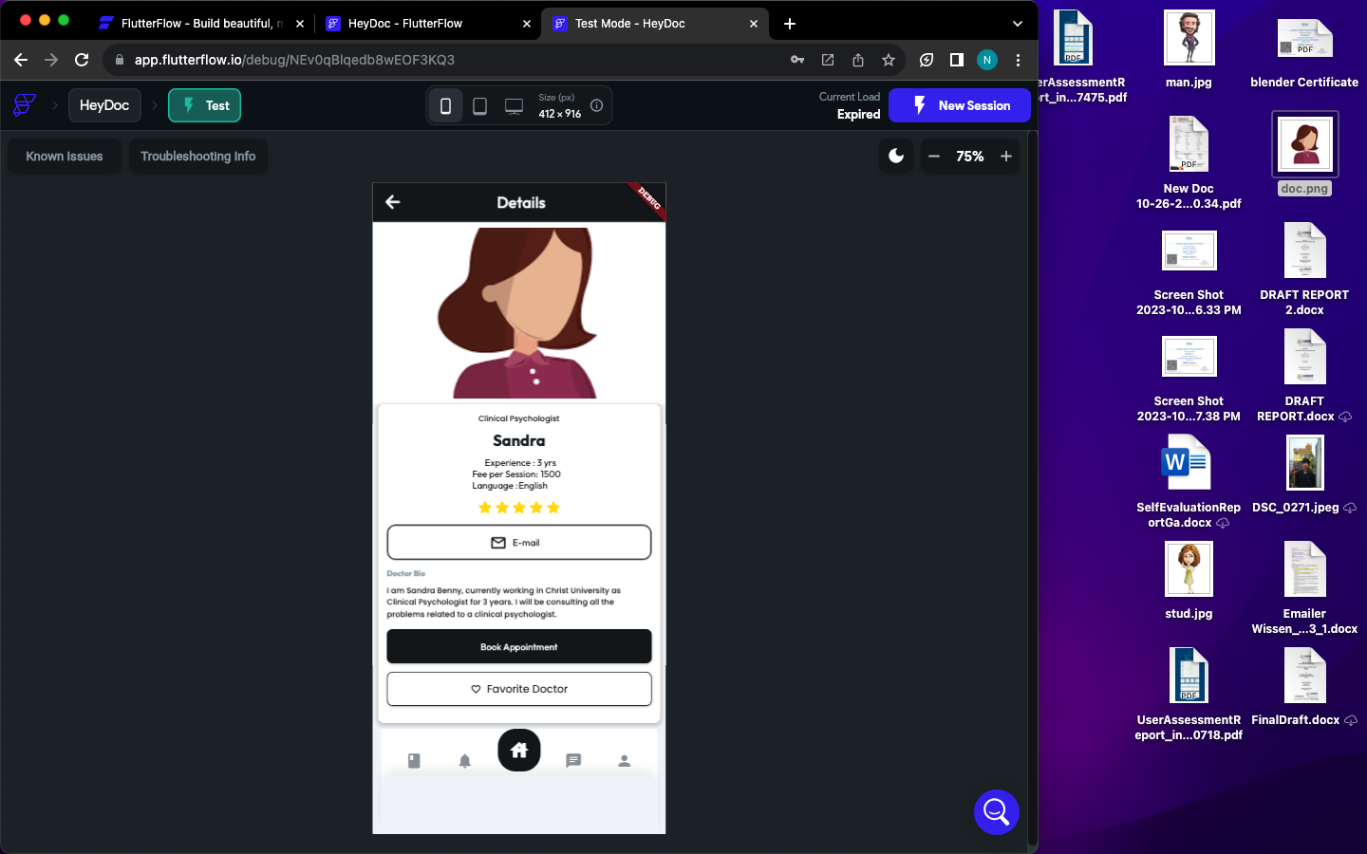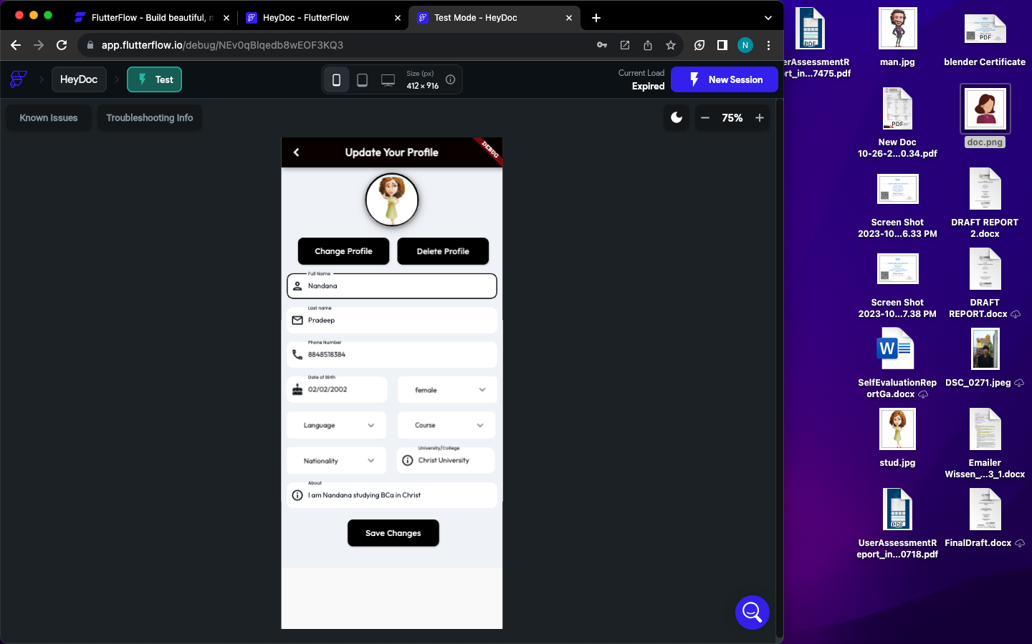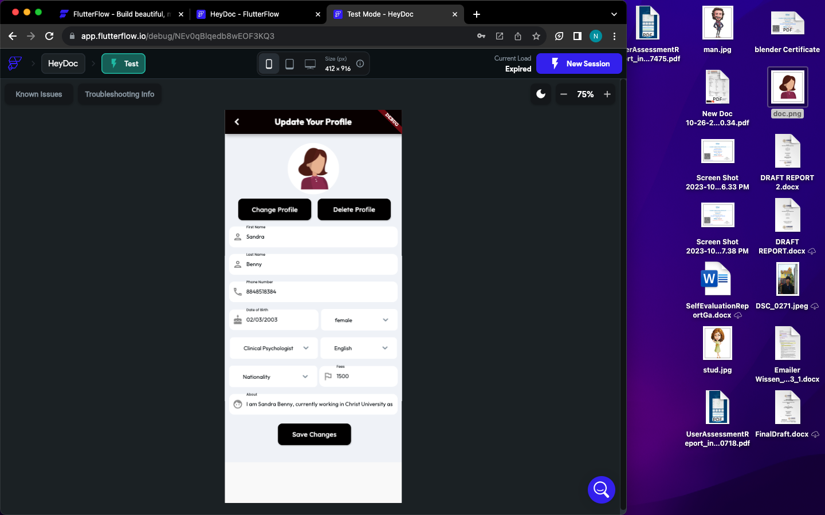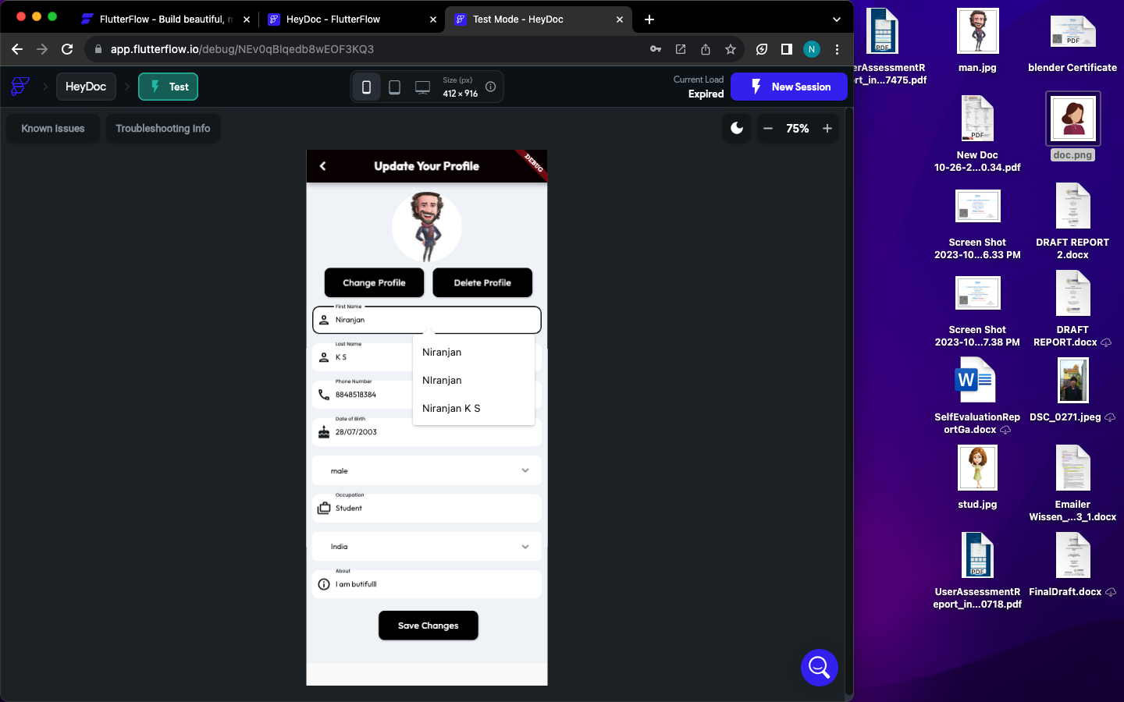**BOOK APPOINTMENTS**

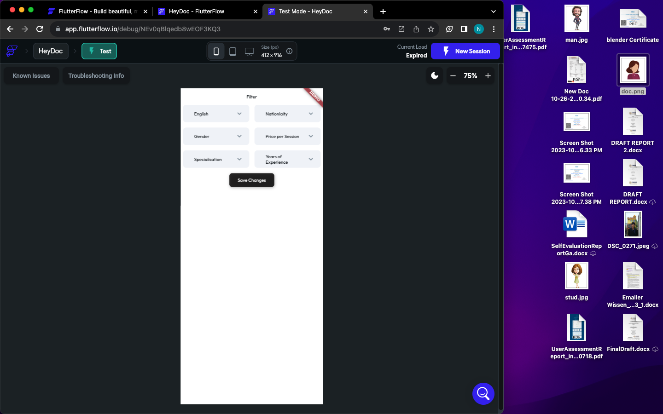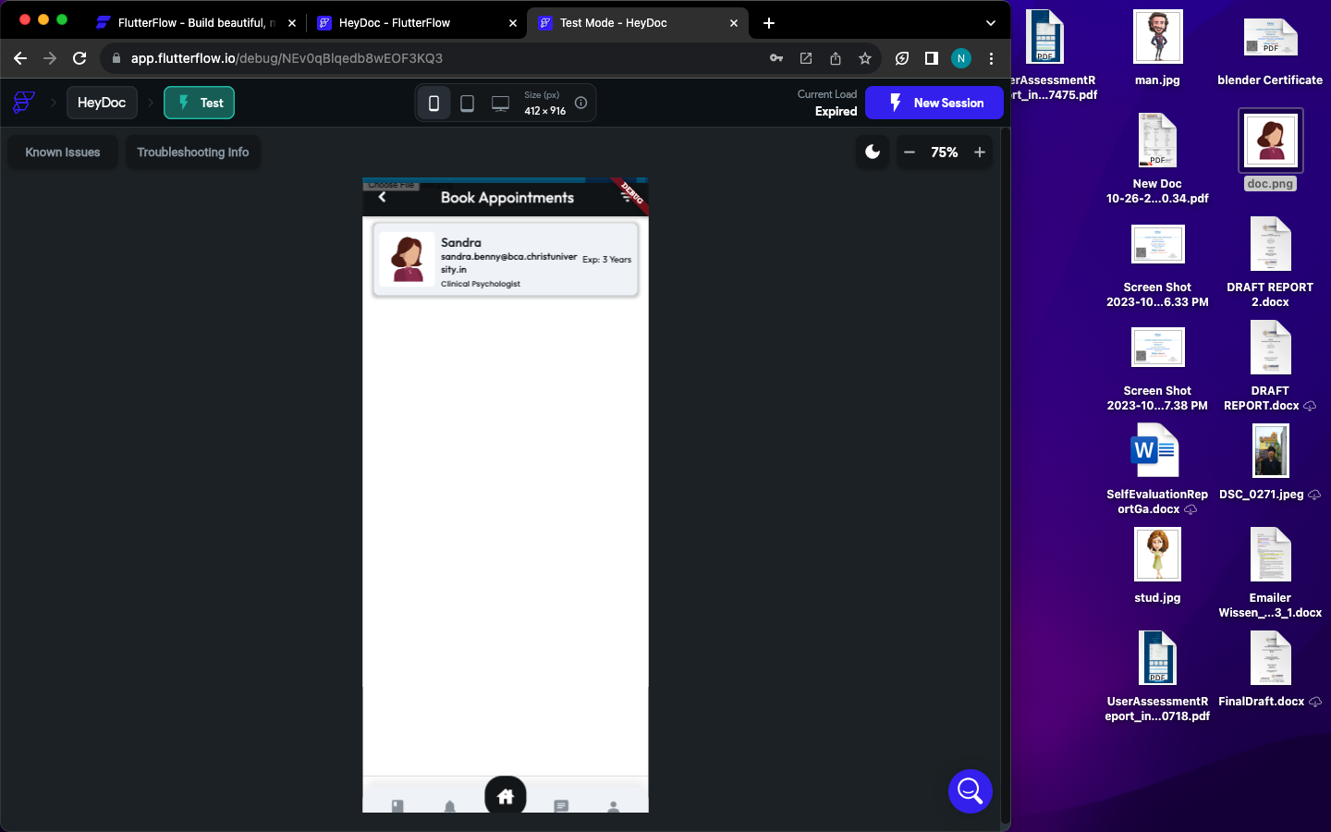

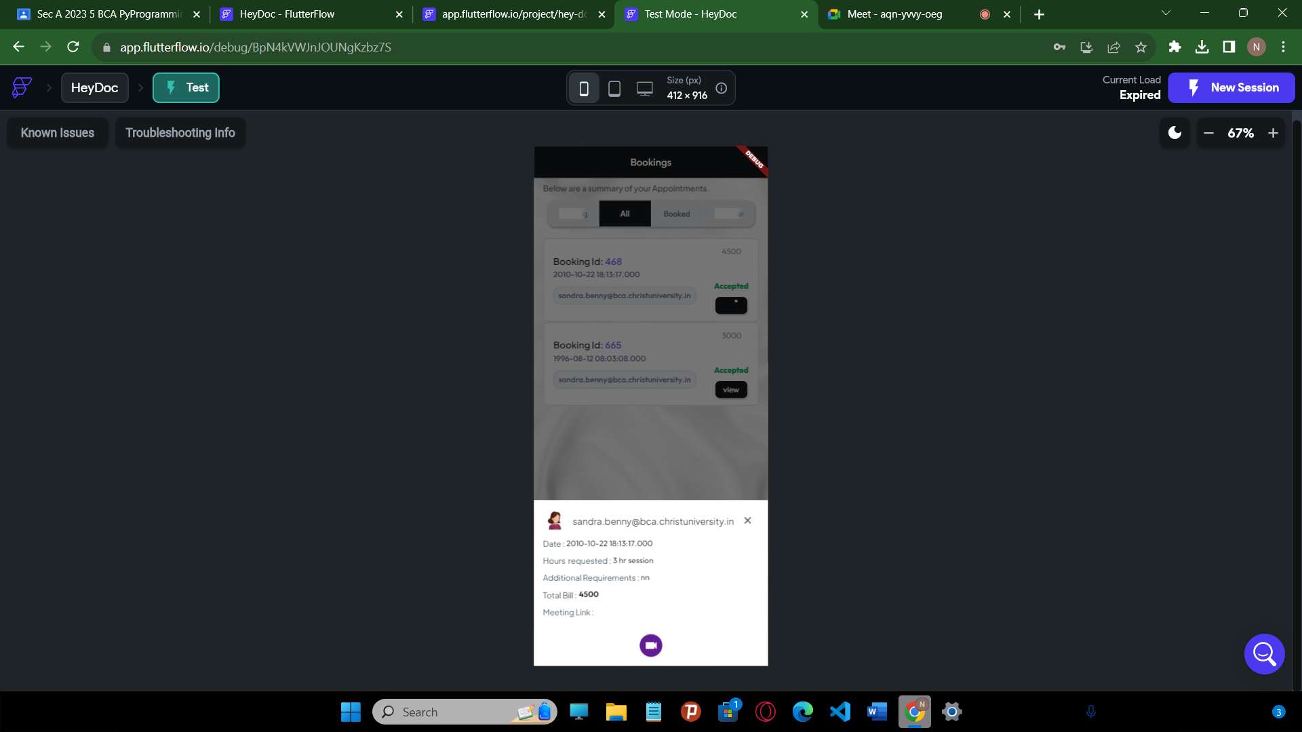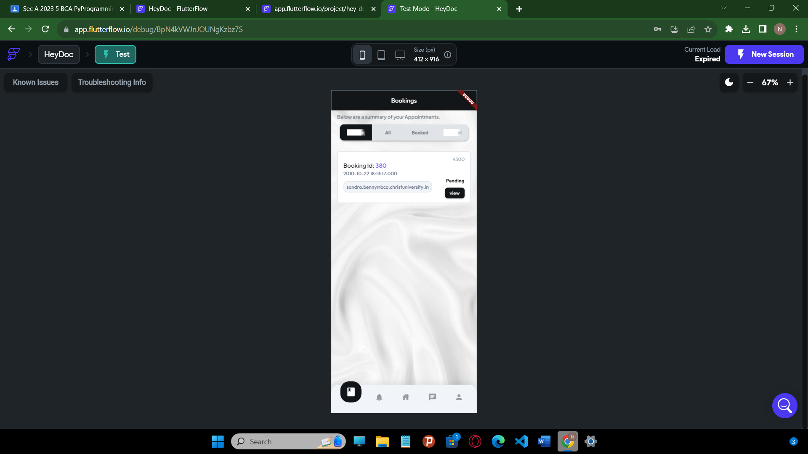**BOOK APPOINTMENTS**

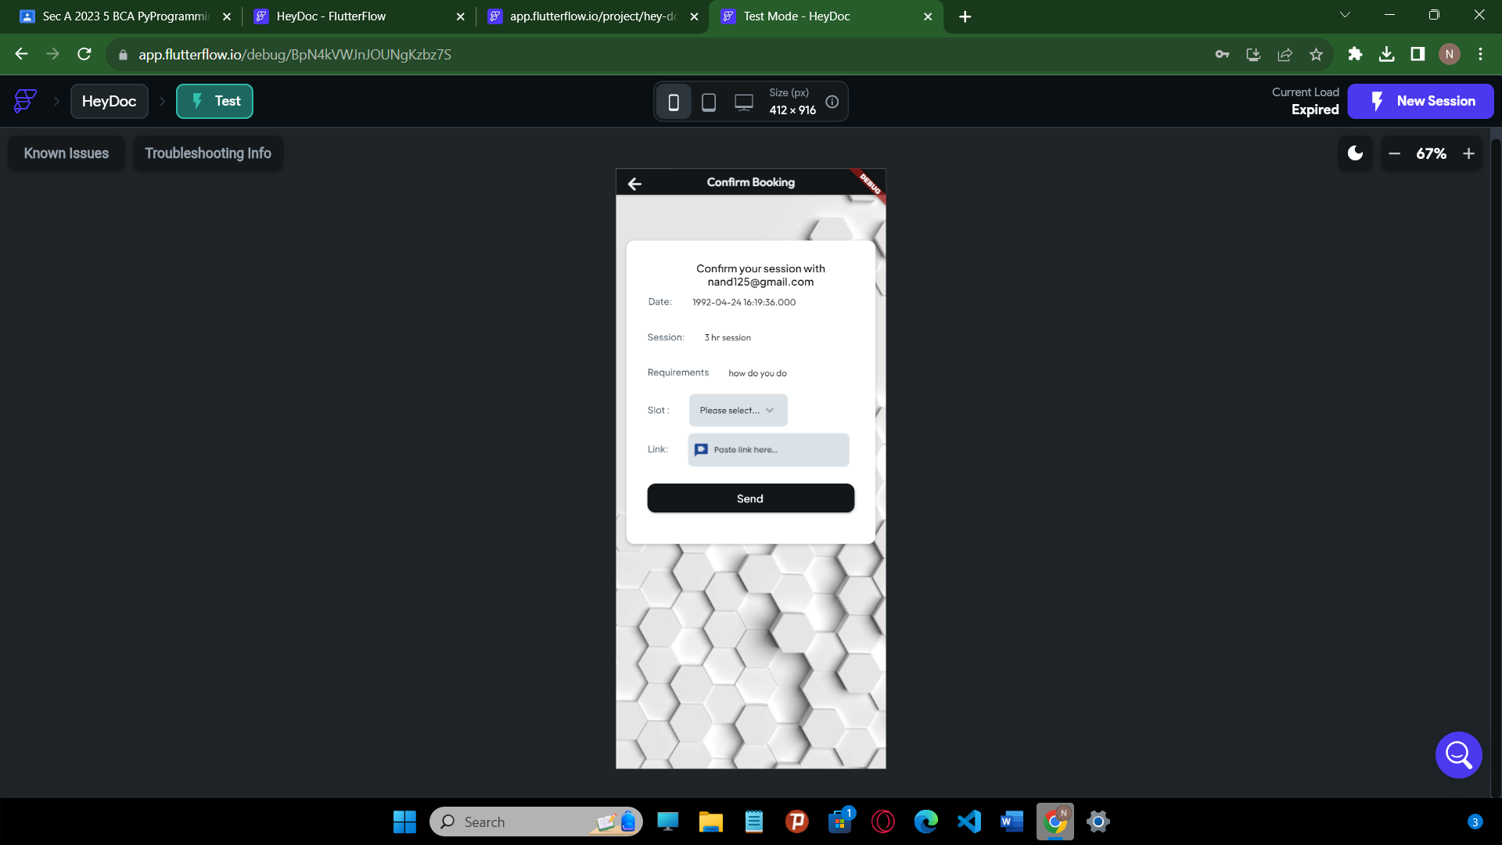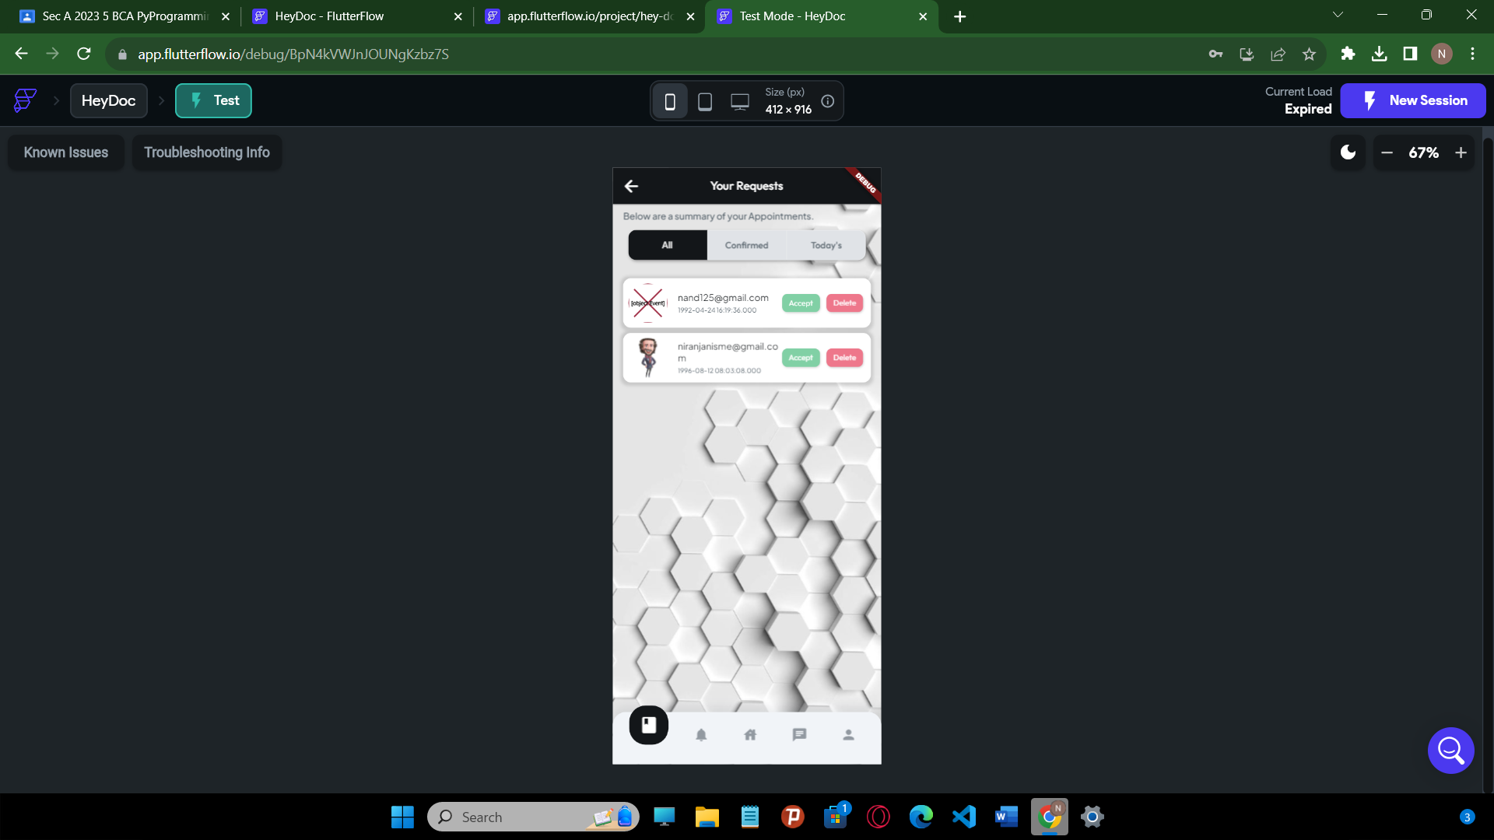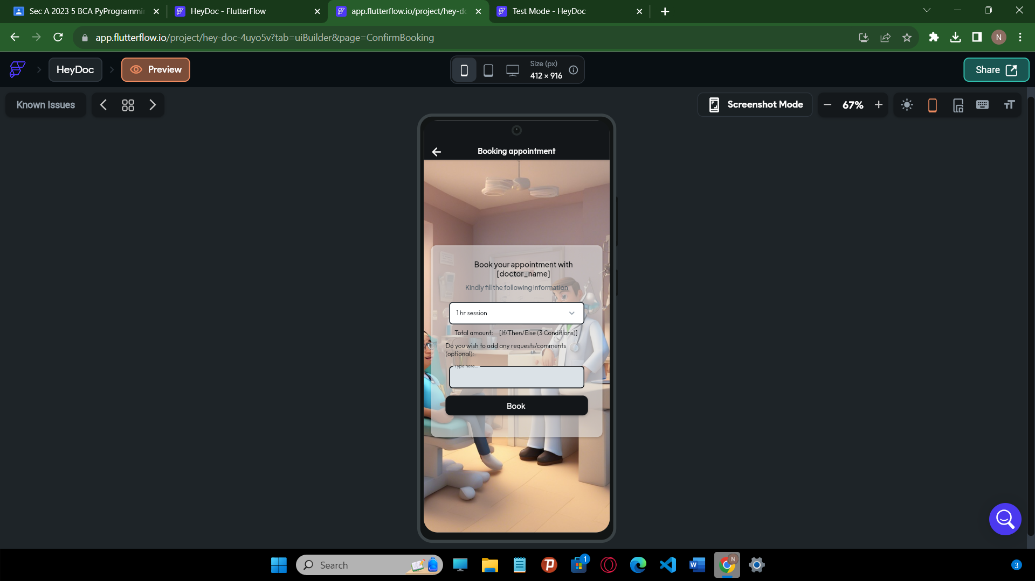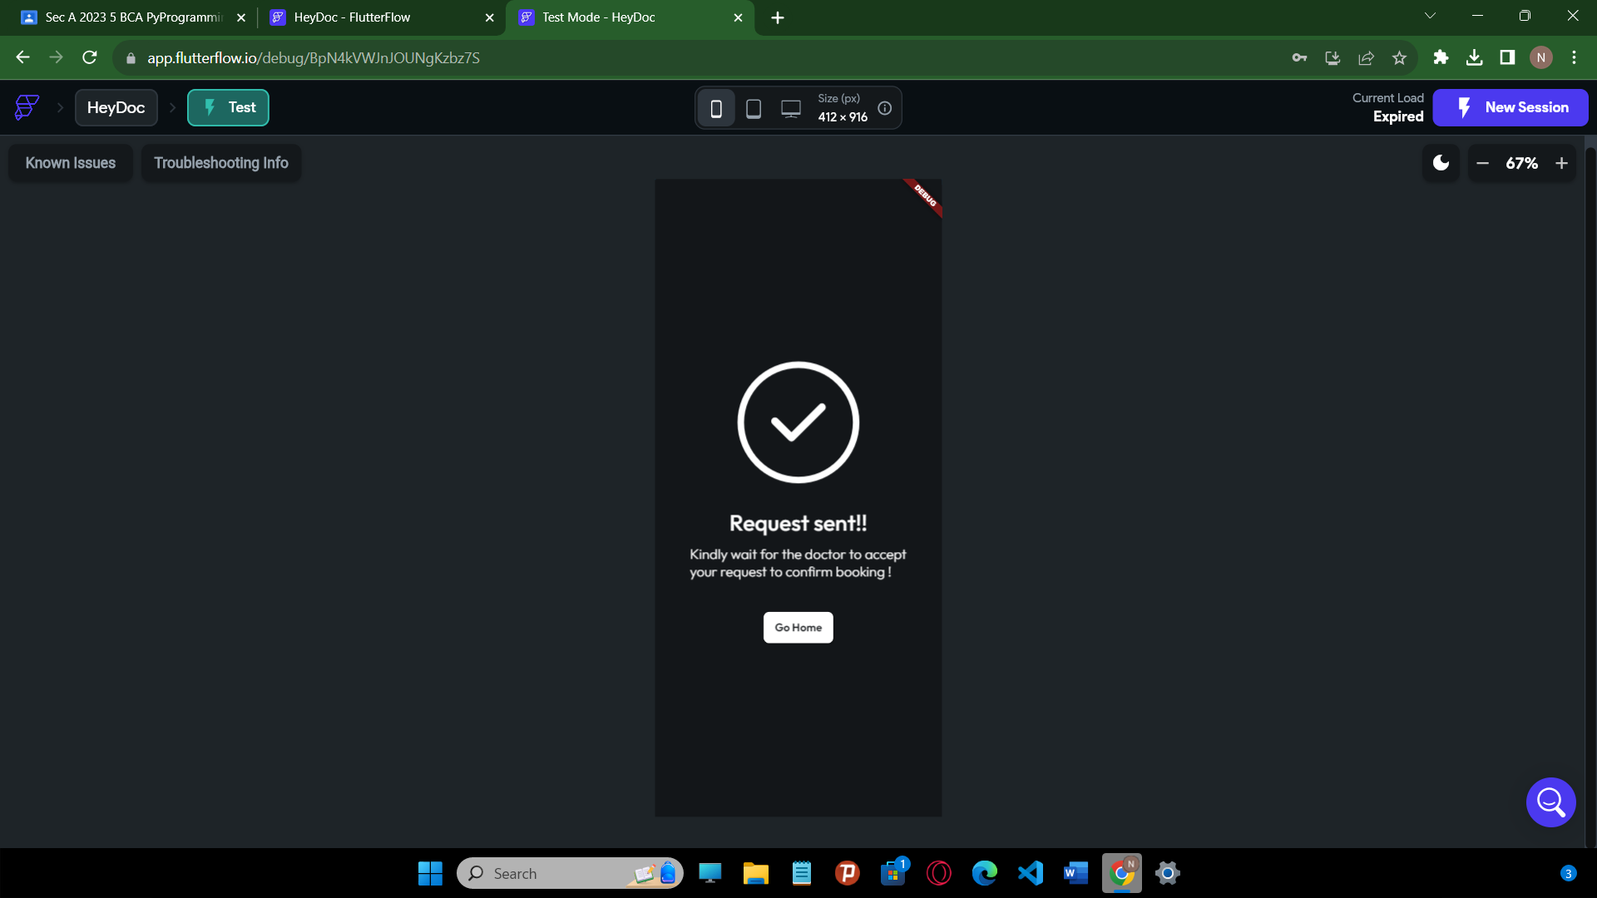

**MEDITATION PAGES**

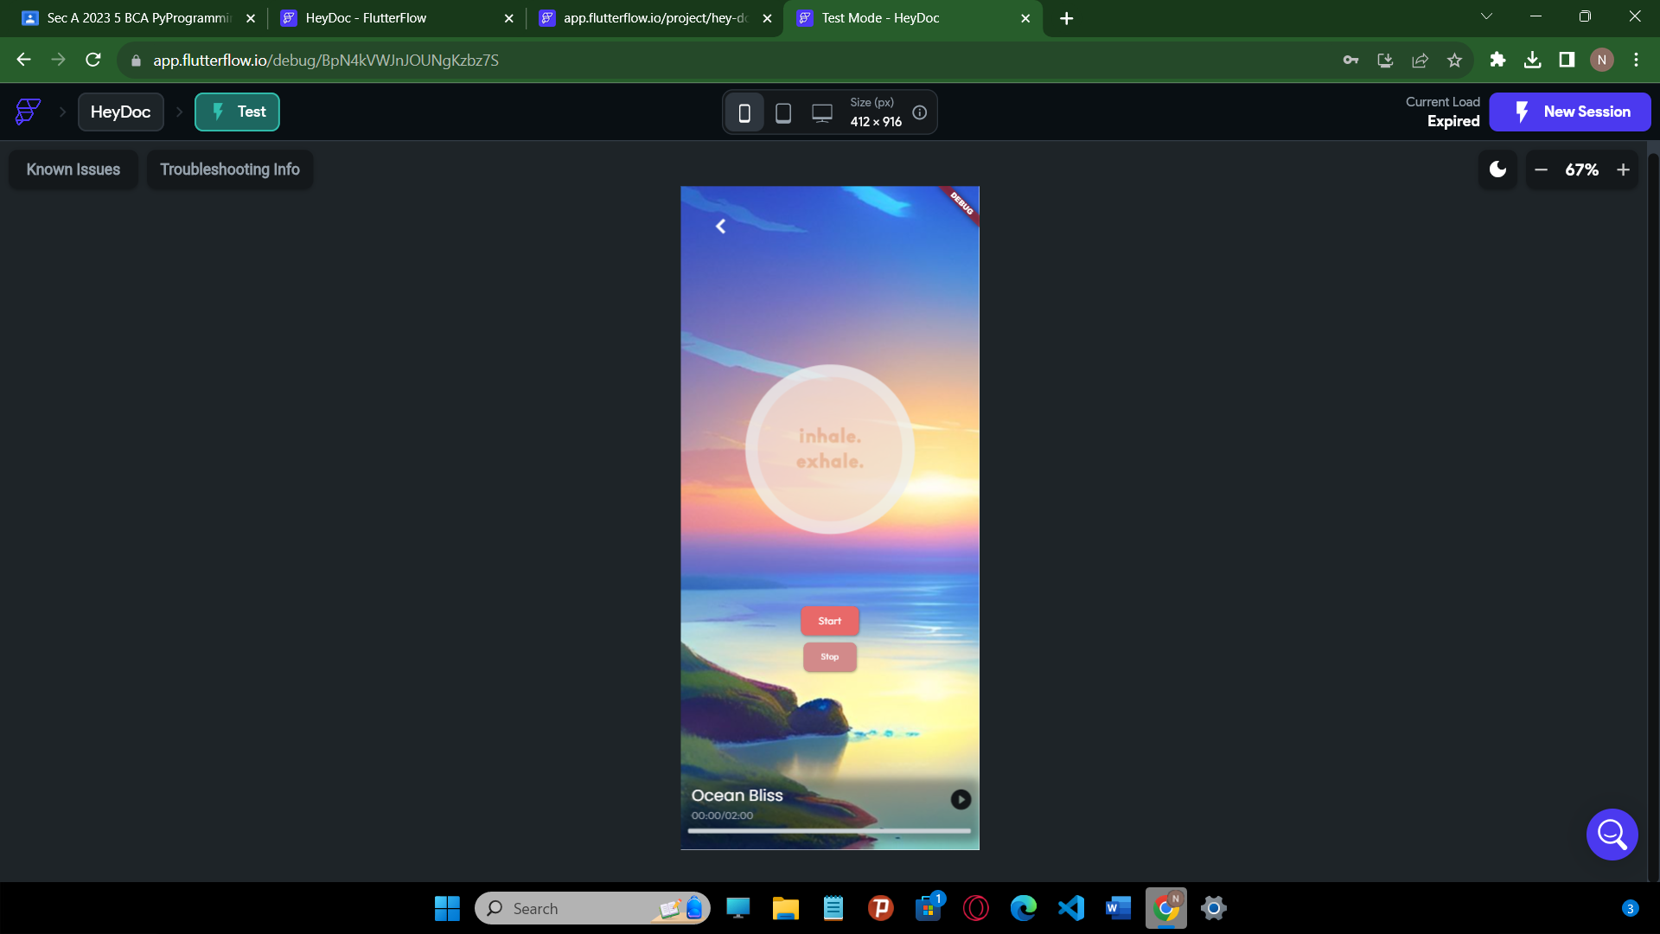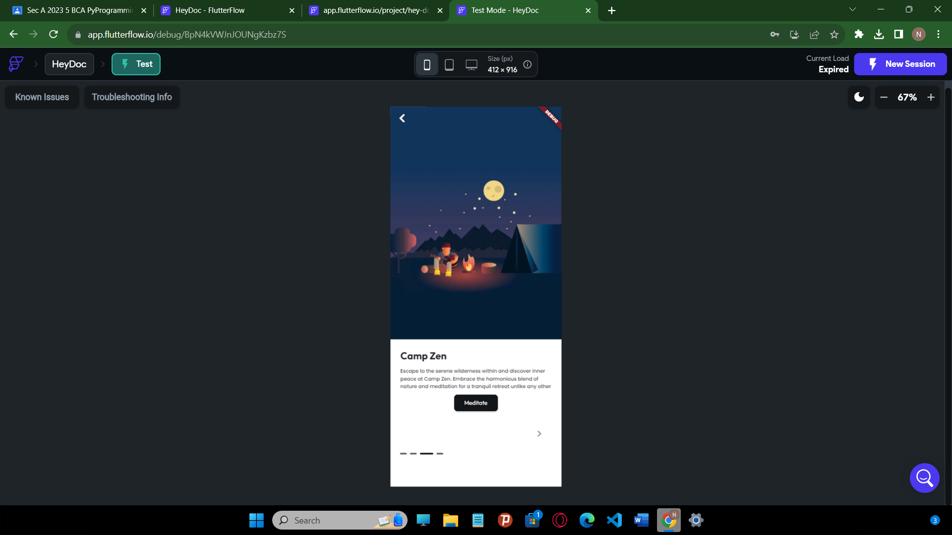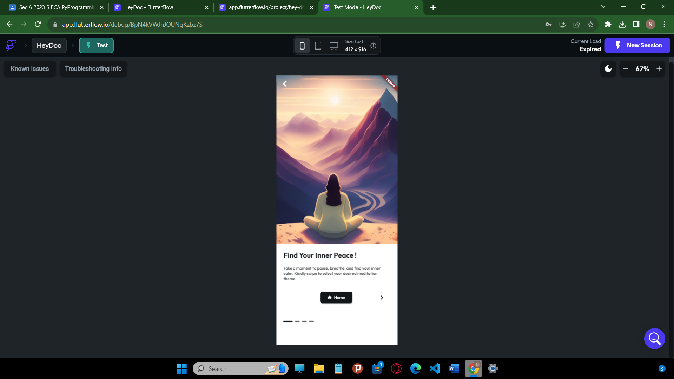

**CHAT PAGE**

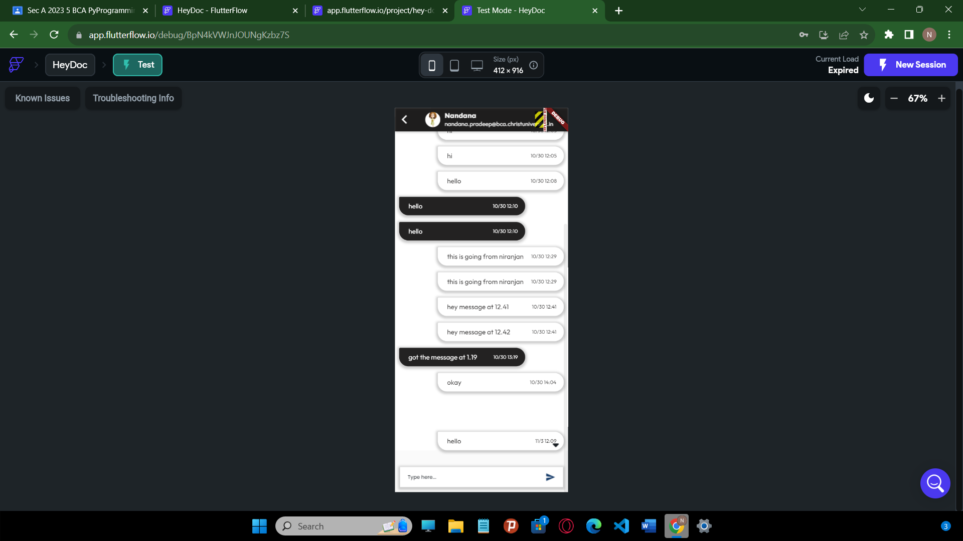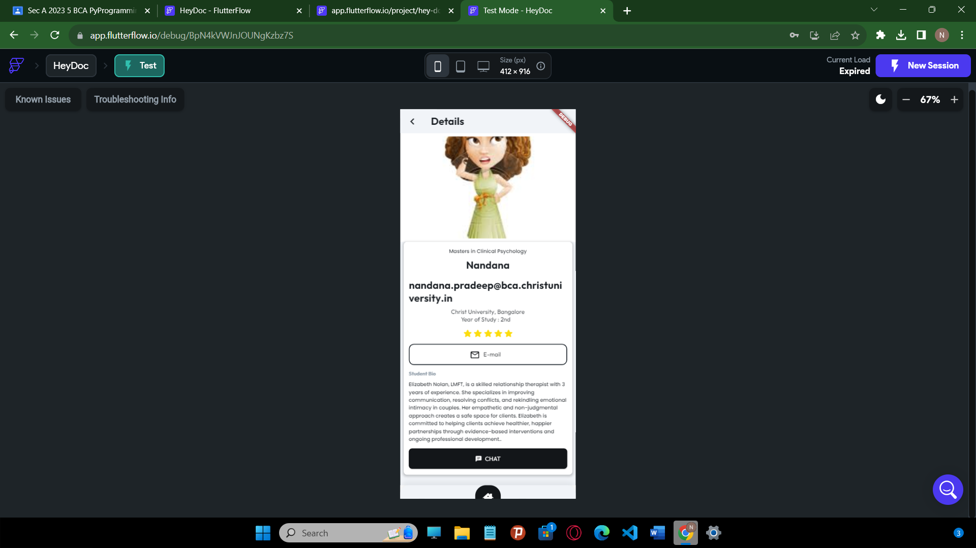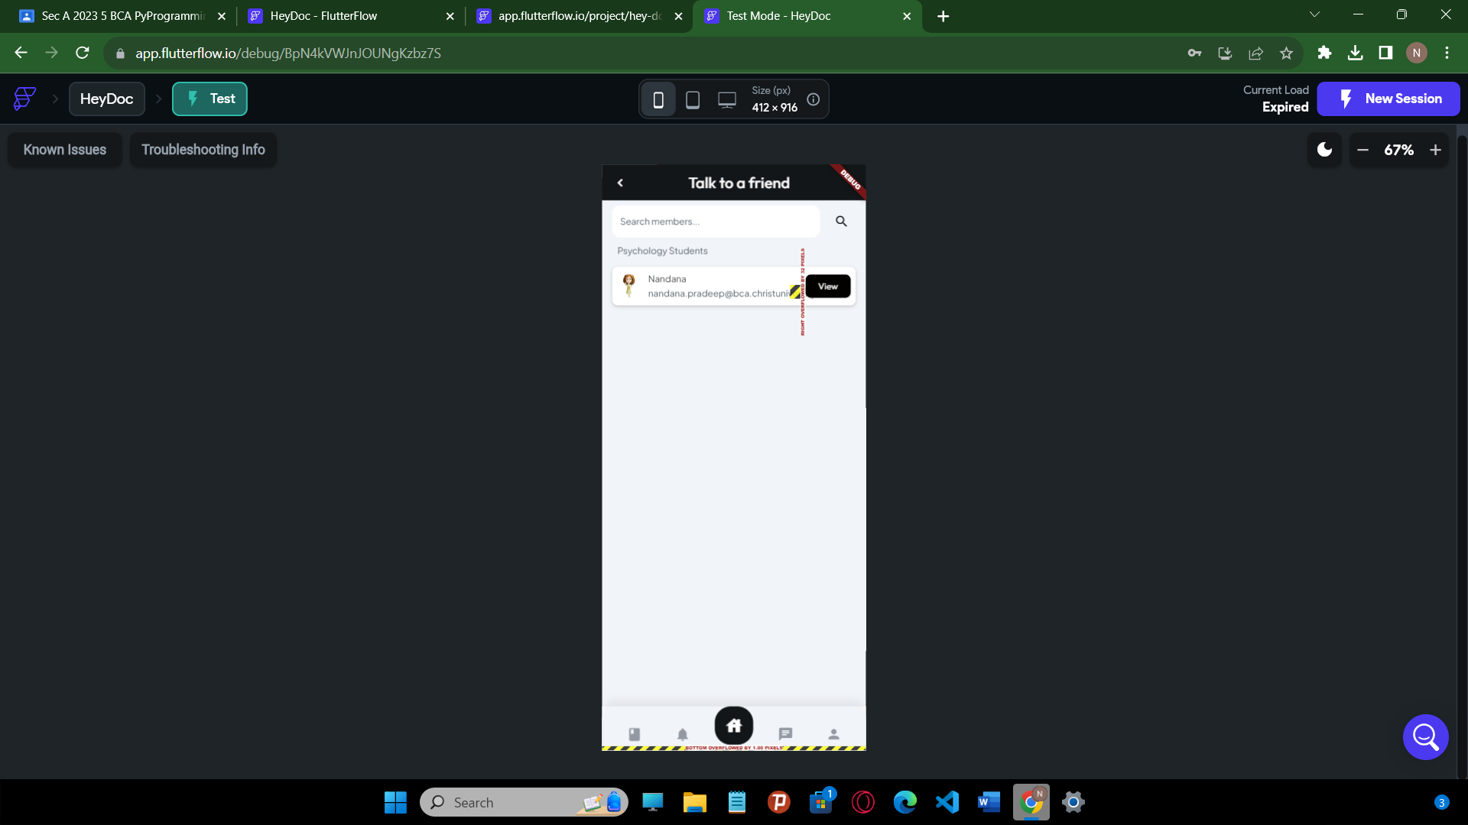

1. **TESTING**

**5.1 TEST STRATEGIES**

A strategy for software testing integrates software test cases into a series of well-planned steps that result in the successful construction of software. Software testing is a broader topic for what is referred to as verification and validation. Verification refers to the set of activities that ensure that the software that has been built is traceable to the customer’s requirements.

**Testing Steps:**

* **Unit testing**

Unit testing means testing each unit of the design separately. Here in this project, we tested each unit of design separately and verified that there were no errors. For this testing each design is run individually After executing each page if any error occurs correction mechanism is done instantly.

* **Integration testing**

In our project, we combine many units of modules to form a sub-system. These sub-systems are then tested. This is done to see whether the modules can be integrated properly. Based on integration testing some necessary changes were made to the design.

* **System testing**

System testing is done to ensure the entire software performs its function as intended. In our project, all the tested subsystems were integrated and tested for all the possible ranges of coupling variables, and based on the testing errors were rectified for a pleasant working experience.

* **Acceptance testing**

The goal of acceptance testing is to see if the software meets all the requirements as needed. The testing was performed by data of all the users of the system. It was found that the software meets all the requirements of the host, tenant, administrator, and service providers as needed.

**5.2 TEST CASES AND REPORTS**

Table 1. Login Module Test Case

|  |  |  |  |
| --- | --- | --- | --- |
| **Sr no** | **Login module (1)** | | |
| **1.1** | **Input:** valid details completely | **Output:** successfully logged in | The user is logged into his account and redirected to the dashboard |
| **1.2** | **Input:** incorrect or invalid details | **Output:** Enter valid username/password | The user is prompted to check his username and password. |

Table 2. User Registration Module Test Case

|  |  |  |  |
| --- | --- | --- | --- |
| **Sr no** | **User Sign-up module (2)** | | |
| **2.1** | **Input:** valid details completely | **Output:** successfully registered | The user is registered into the database, and redirected to the search page |
| **2.2** | **Input:** input with certain fields empty | **Output:** Fill all the fields of the form | The user is prompted to fill in all the required fields. |
| **2.3** | **Input:** Enters invalid data in certain fields. | **Output:** Enter valid details in the particular field | The user is prompted to enter valid details in the particular field that is incorrect. |

**5.3 FUTURE ENHANCEMENTS**

In the future, our mental health and therapy management platform will prioritize advanced AI-driven personalization to offer highly tailored treatment plans, leveraging user data for predictive analytics to anticipate potential mental health challenges. The integration of telehealth technologies will further enhance the virtual therapy experience, incorporating interactive features for more effective sessions. Additionally, the expansion of therapy offerings to include group sessions and specialized tracks, along with the introduction of community forums and support groups, will promote a more holistic approach to mental health care. These enhancements aim to provide not only personalized and effective therapy but also a supportive community environment for users, ultimately contributing to improved mental well-being and greater access to mental health care resources.

1. **CONCLUSION**

In conclusion, our project represents a significant step forward in the field of mental health and therapy management. Through a comprehensive and user-focused approach, we have developed a sophisticated digital platform that addresses the diverse needs of individuals seeking mental health support. Our system incorporates a wide range of features, from user registration with licensed therapists and engaging stress relief games. This multifaceted approach not only enhances accessibility to mental health care but also empowers users to actively engage in their mental well-being journey.

As we navigate an era where mental health awareness and care are of paramount importance, our project offers a timely and invaluable solution. It embodies a commitment to improving mental health outcomes, reducing stigma, and providing users with the tools they need to lead healthier and happier lives. Our platform represents a promising contribution to the ever-evolving landscape of mental health care, and we are confident that it will make a meaningful difference in the lives of those who seek its support.

**REFERENCES**

* **FIREBASE**

<https://console.firebase.google.com/u/0/?pli=1>

* **FLUTTER FLOW**

https://app.flutterflow.io/